Name: Nayan Rajani

Organization: Blazeclan Technologies

E-mail: [nayan.rajani@blazeclan.com](mailto:nayan.rajani@blazeclan.com)

Assignment: ACE+

1. **Create a simple website, running on 2 origin web servers**

**OCT application team would like to use Cloudflare for 2 applications:**

web.greencoin.cf

app.greencoin.cf

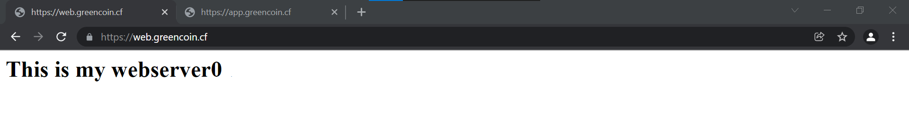

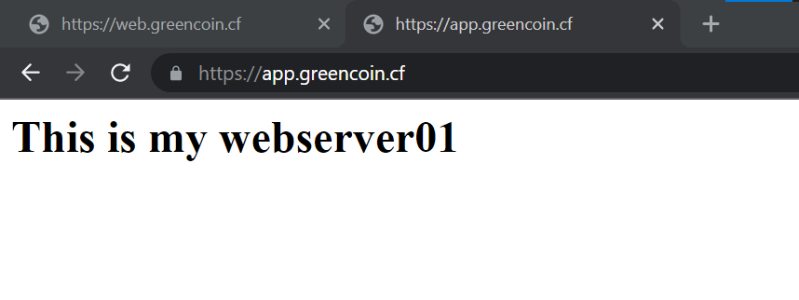

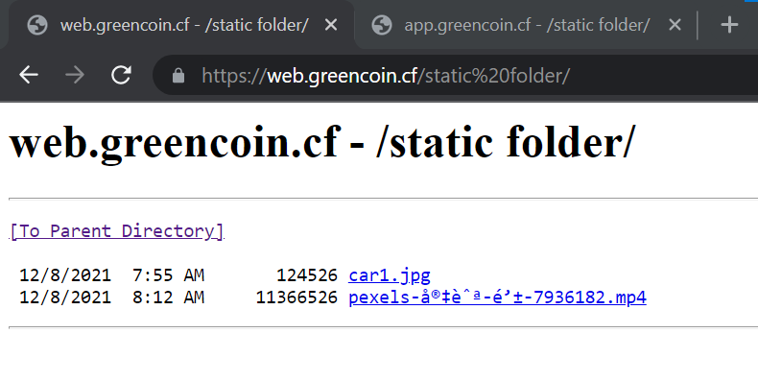

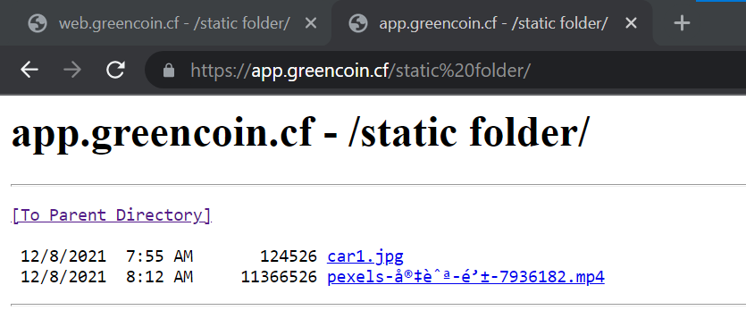

**2. DNS/SSL**

**2.A Deploy a ECDSA origin cert on the origin and secure the communication between Cloudflare and the origin using SSL Full (Strict) mode**

DNS Configurations!!

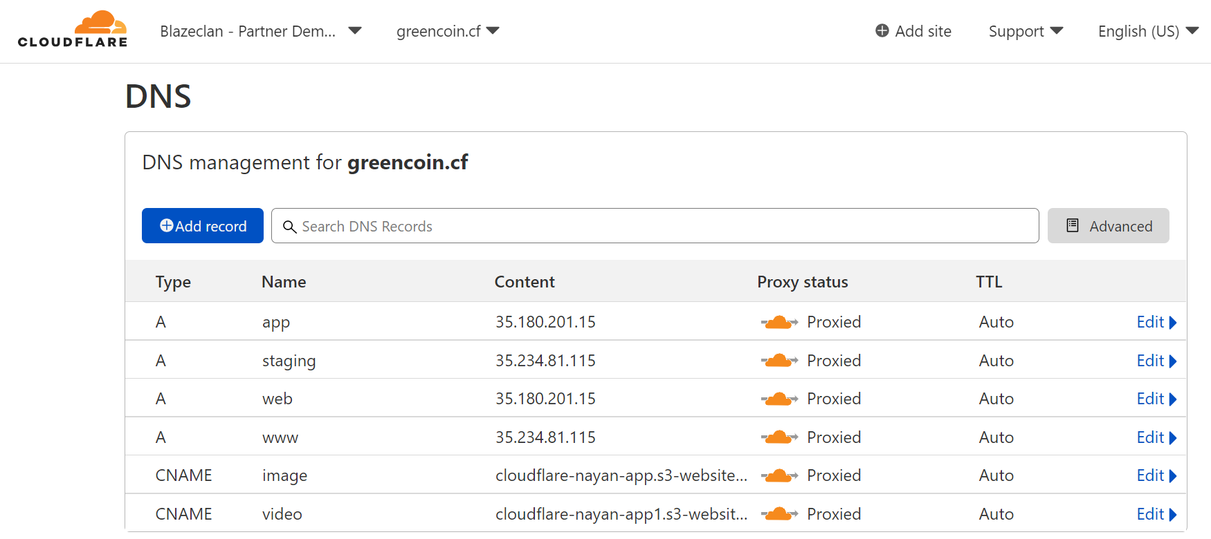

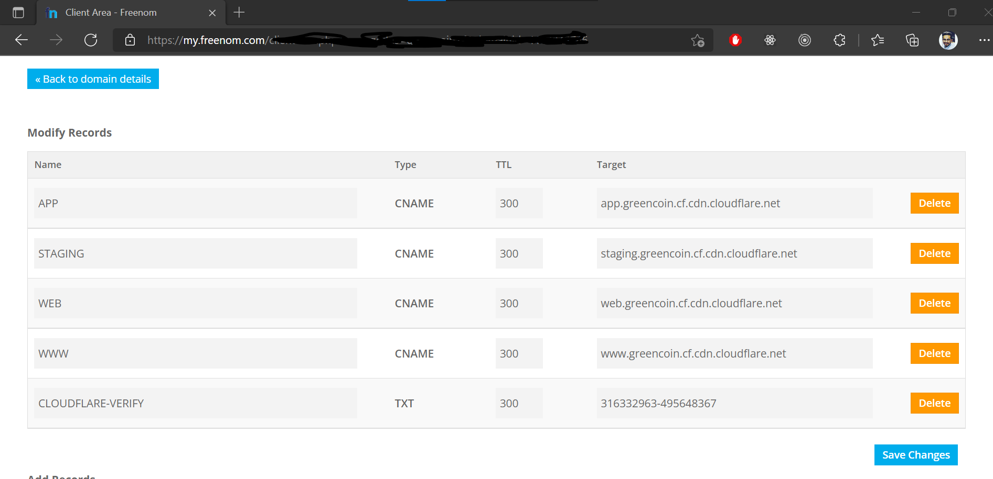

1. Configuring the CA origin using SSL Full (Strict) mode   
   Path: Dashboard -> SSL/TLS Overview -> Change

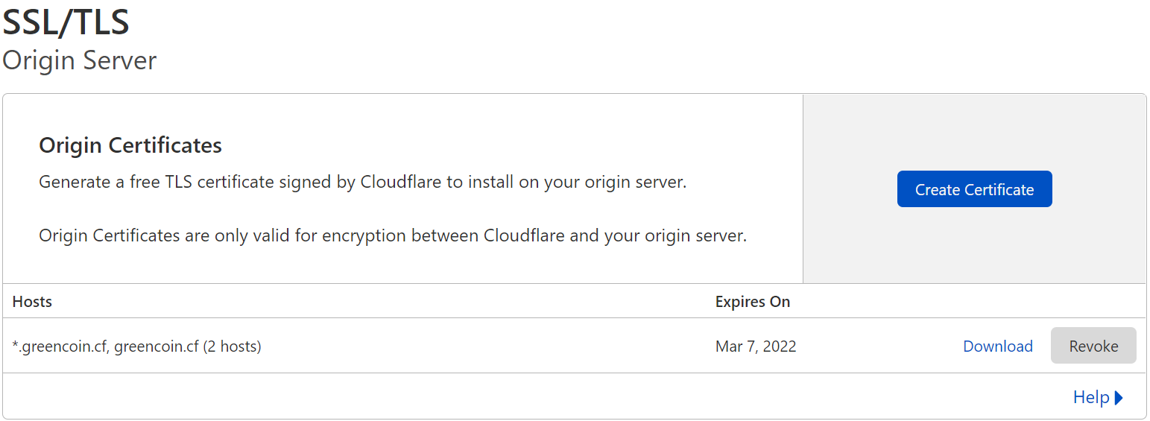

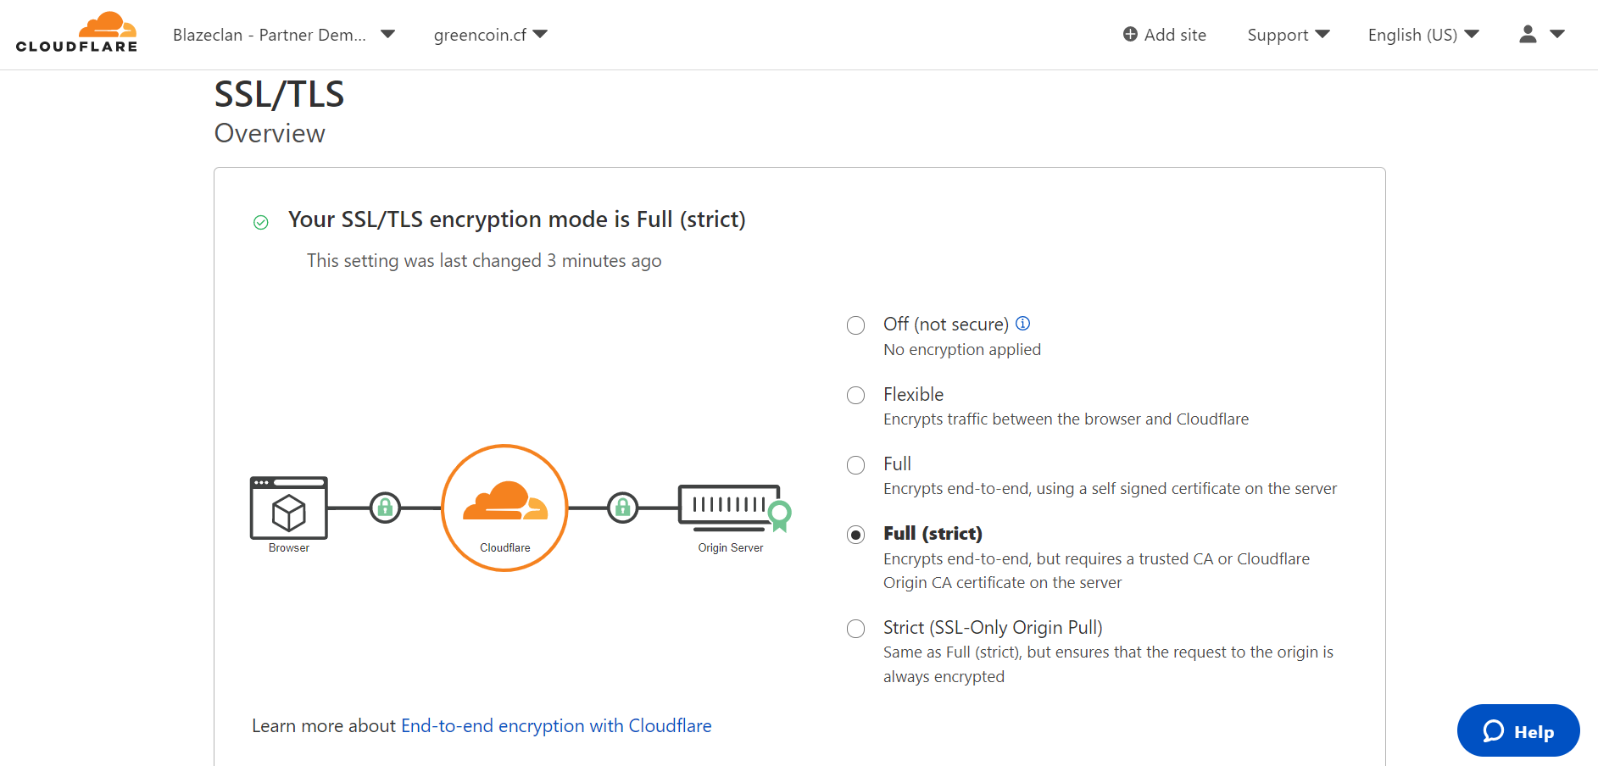

1. Deploy a ECDSA origin cert on the origin  
   Path: Dashboard -> Origin Server -> Origin Certificate -> Create Certificate
   * After this Copy your Certificate and Private key in any format, I have chosen PEM format, then click on ok.

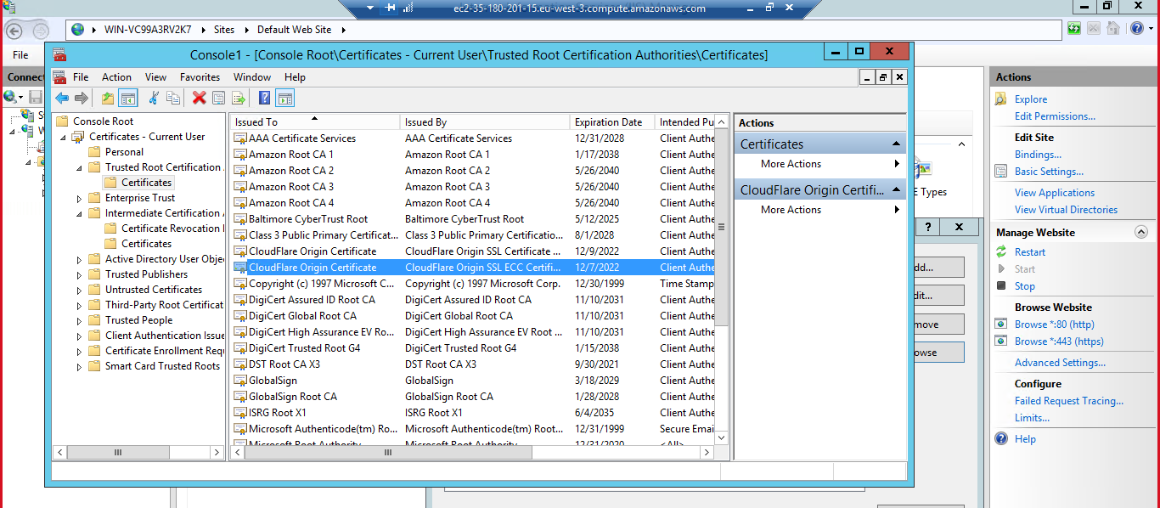

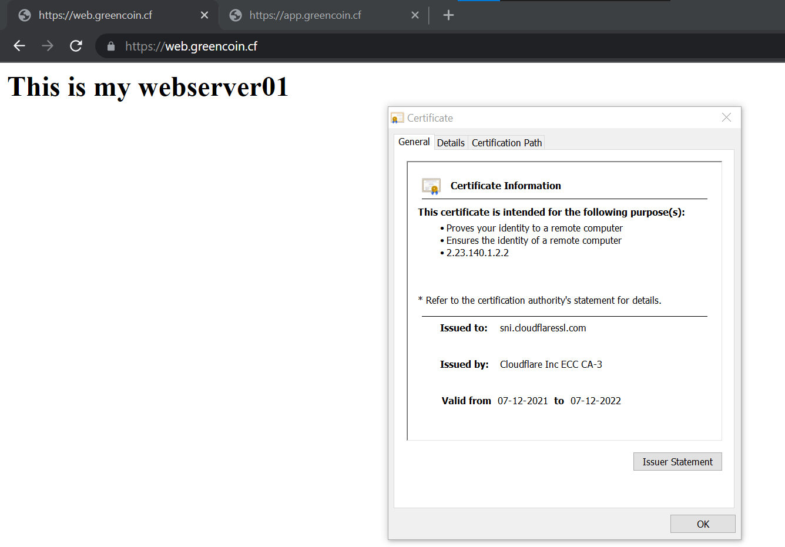

**2.B Describe the difference between SSL mode Flexible, Full and Full (strict)**

* CloudFlare provides free CDN and also it provides free SSL. When adding SSL there will be five options like i) off ii) Flexible iii) Full iv) Full (Strict) v) Strict (SSL-only Origin Pull)

1. Flexible:
   1. There will be certificates between User and CloudFlare. No Certificates Between CloudFlare and Server.
   2. Setting your encryption mode to Flexible makes your site partially secure
   3. Edge to origin not encrypted
   4. Self-signed certificates are not supported
   5. As a result, an SSL certificate is not required on your origin.

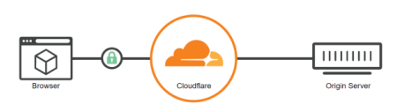

1. Full:
   1. There will be certificates between User and CloudFlare. There will be Certificates Between CloudFlare and Server
   2. If your visitor uses http, then Cloudflare connects to the origin using plaintext HTTP and vice versa. The certificate presented by the origin will not be validated in any way.
   3. Edge to origin certificates can be self-signed

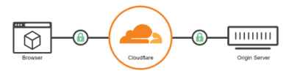

1. Full (strict)-> Recommended
   1. Encrypts end-to-end
   2. Requires a trusted CA or Cloudflare Origin CA certificate
   3. Strong certificates between User and CloudFlare. Strong Certificates Between CloudFlare and Server.
   4. Issued by a publicly trusted certificate authority or Cloudflare’s Origin CA. Contains a Common Name (CN) or Subject Alternative Name (SAN) that matches the requested or target hostname.

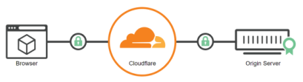

**2.C Bonus (1 point): deploy a custom vanity NS server on your zone**

* Was searching and trying to concentrate on the NS server (Name server) got to know how to configure this from a cloudflare site!
* <https://support.cloudflare.com/hc/en-us/articles/200169006-Setting-up-Custom-Nameservers-at-Cloudflare>

**3. Firewall**

**3 A. Enable both the Cloudflare Managed Rulesets and the OWASP ruleset on the entire zone. Set OWASP threshold to low,**

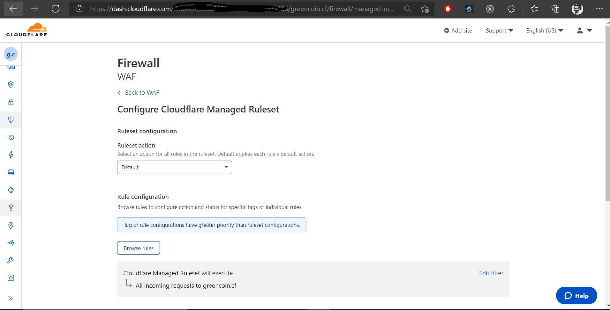

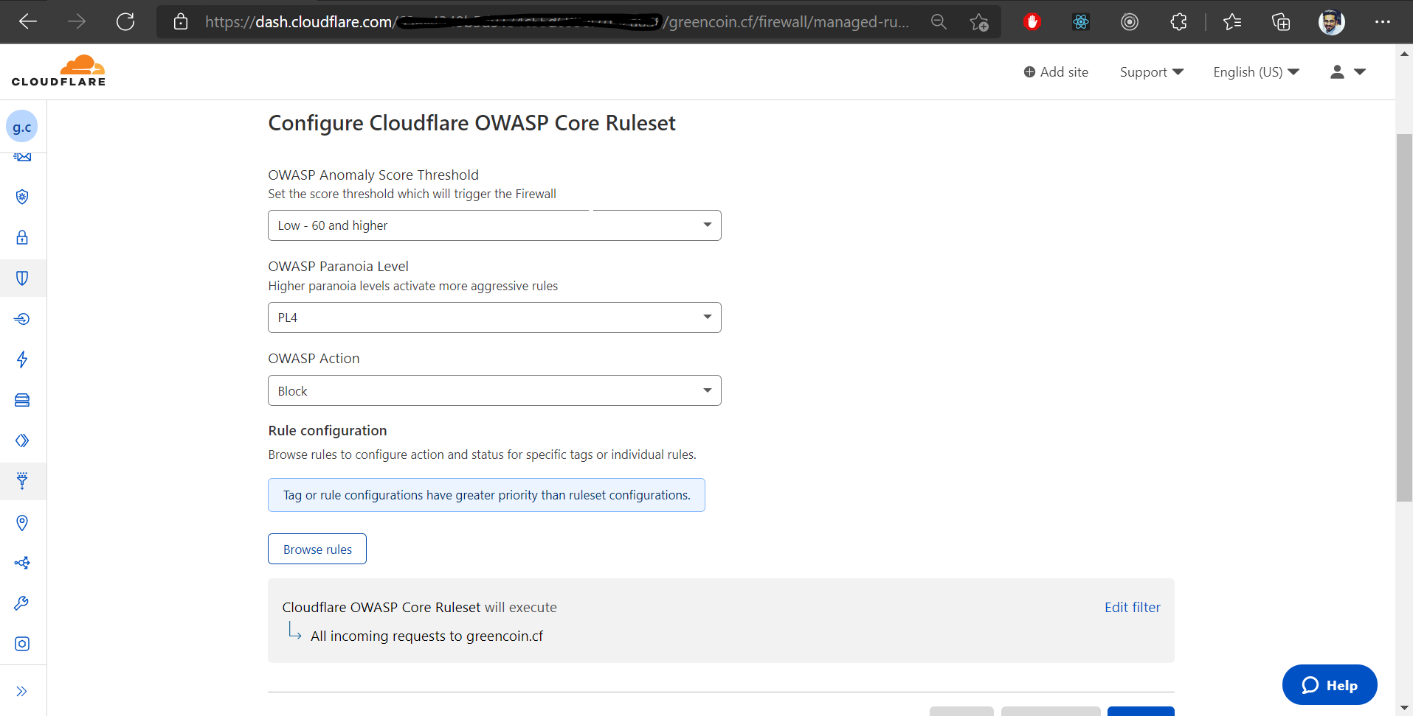

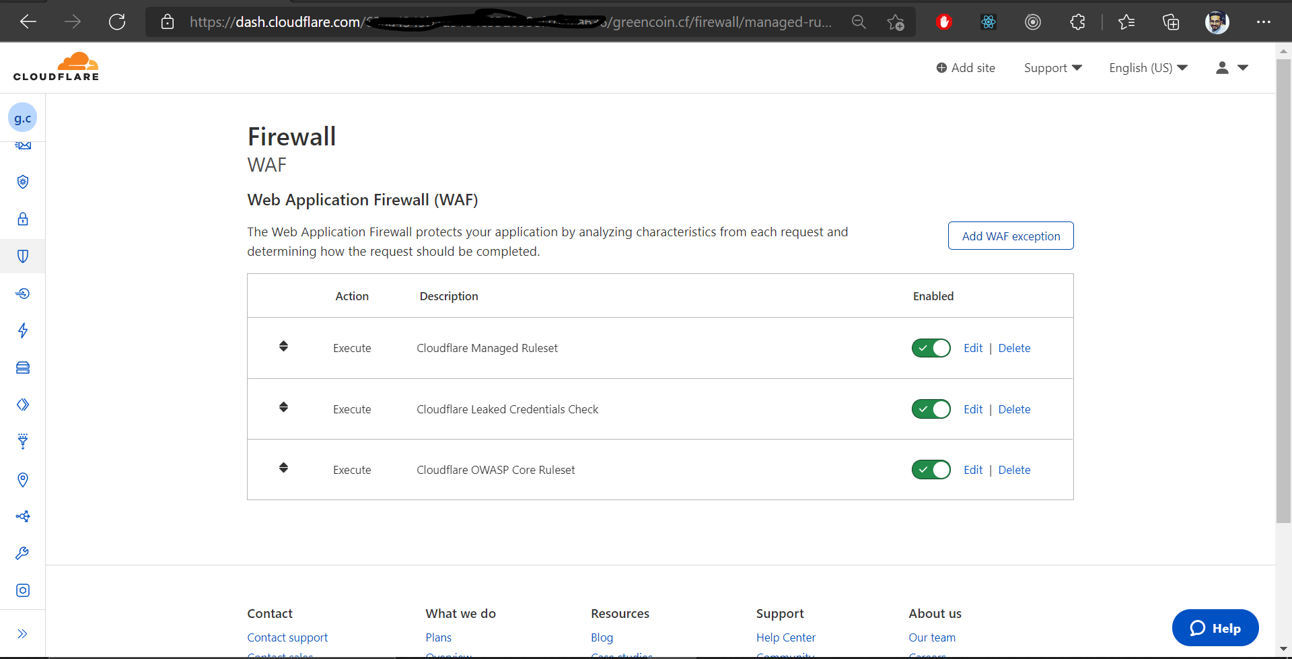

**3.B. Create a Firewall Rule to block request to app.greencoin.cf/admin from any IP in Singapore, unless that request contains a cookie: "cf_bypass=true"**

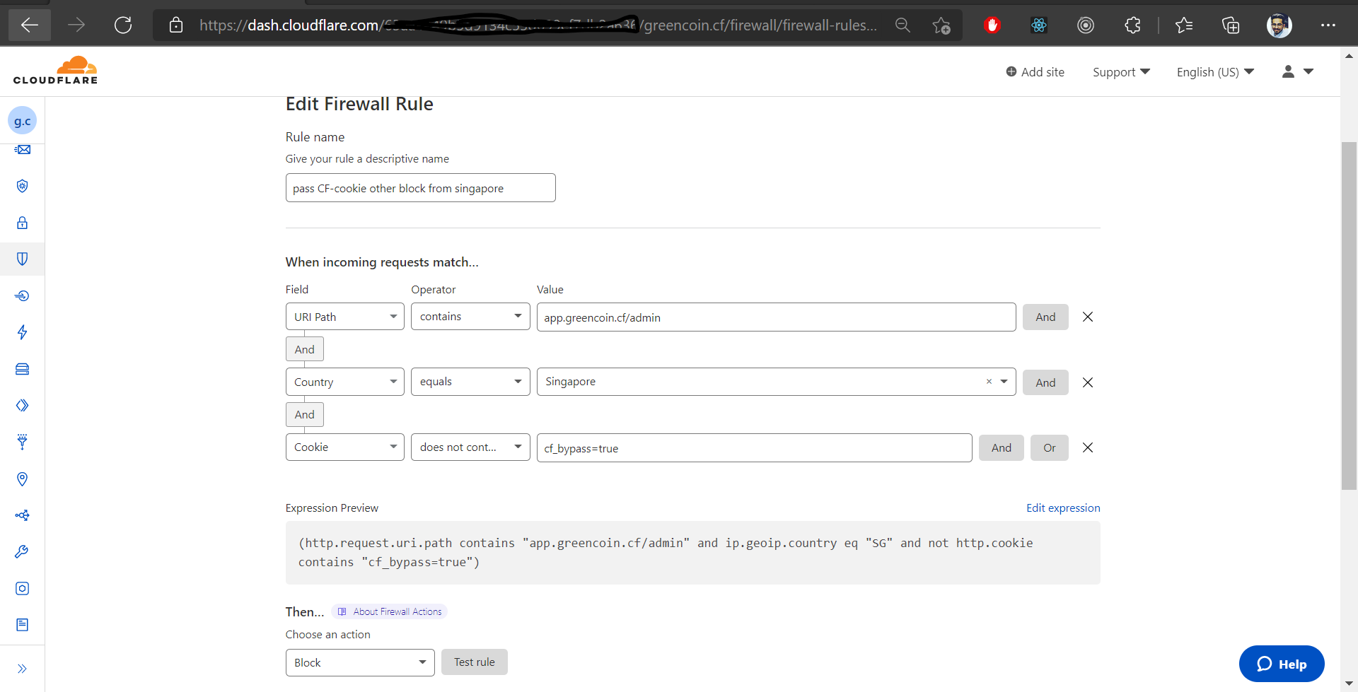

**3.C. Create a Firewall Rule to allow requests going to the app.greencoin.cf/admin to bypass WAF Managed Rulesets and Rate Limiting**

* I was thinking about this “regex” to be implemented and I tried to match the URI first and then the path to match the regex expression!

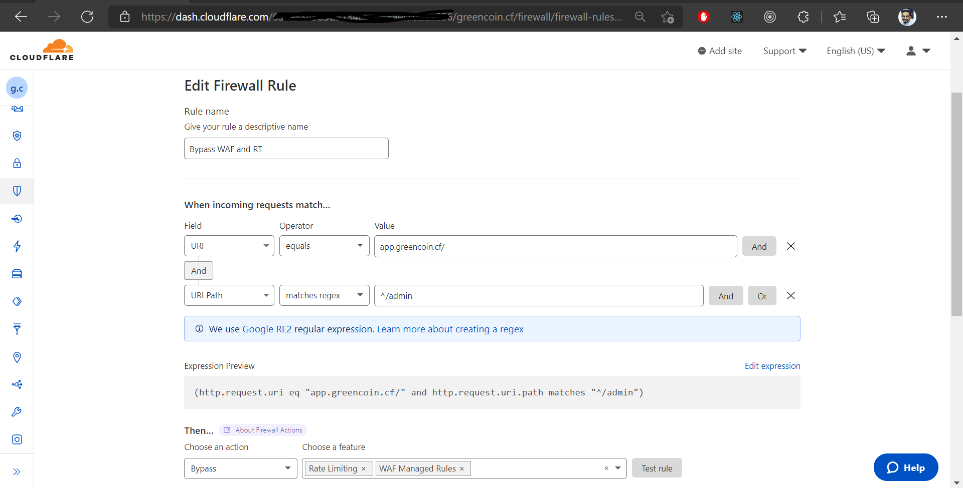

**4. Performance (30 points)**

**4.A. Ensure that all static html pages are cached at Cloudflare edge for 1 day**

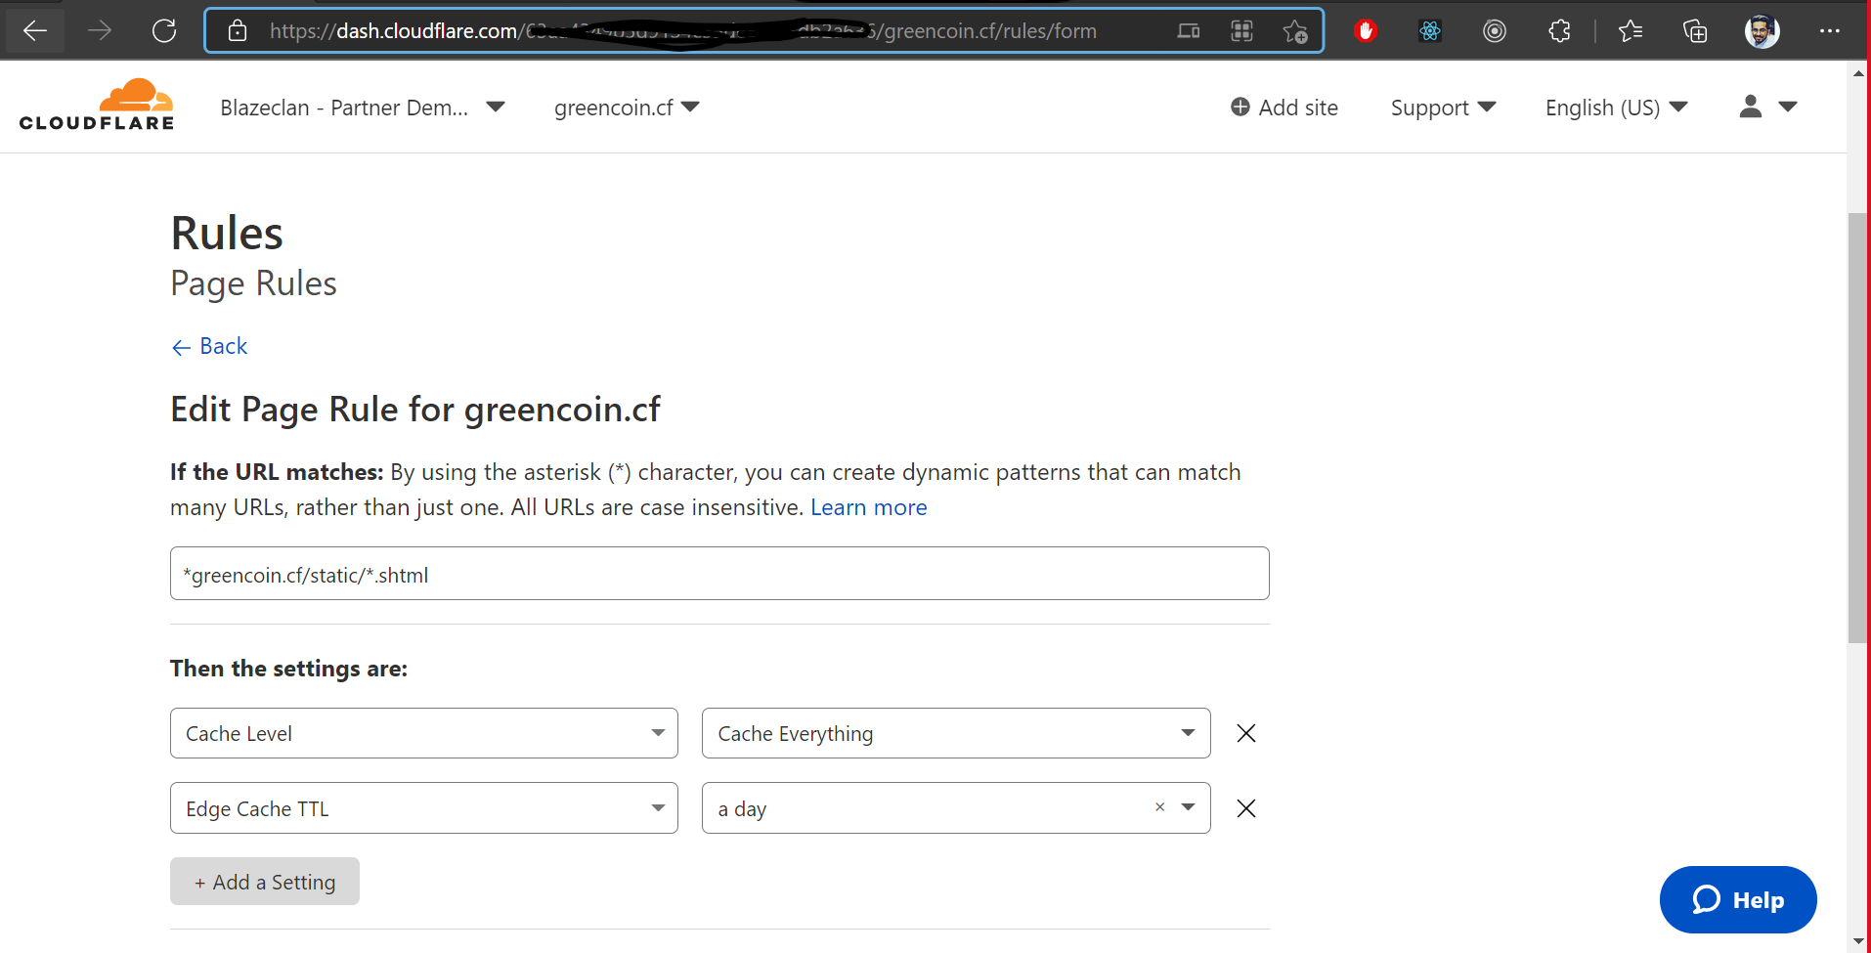

**4.B. Ensure that all static files under /static directory should be cached at Cloudflare edge for 1 hour and in browser for 4 hours**

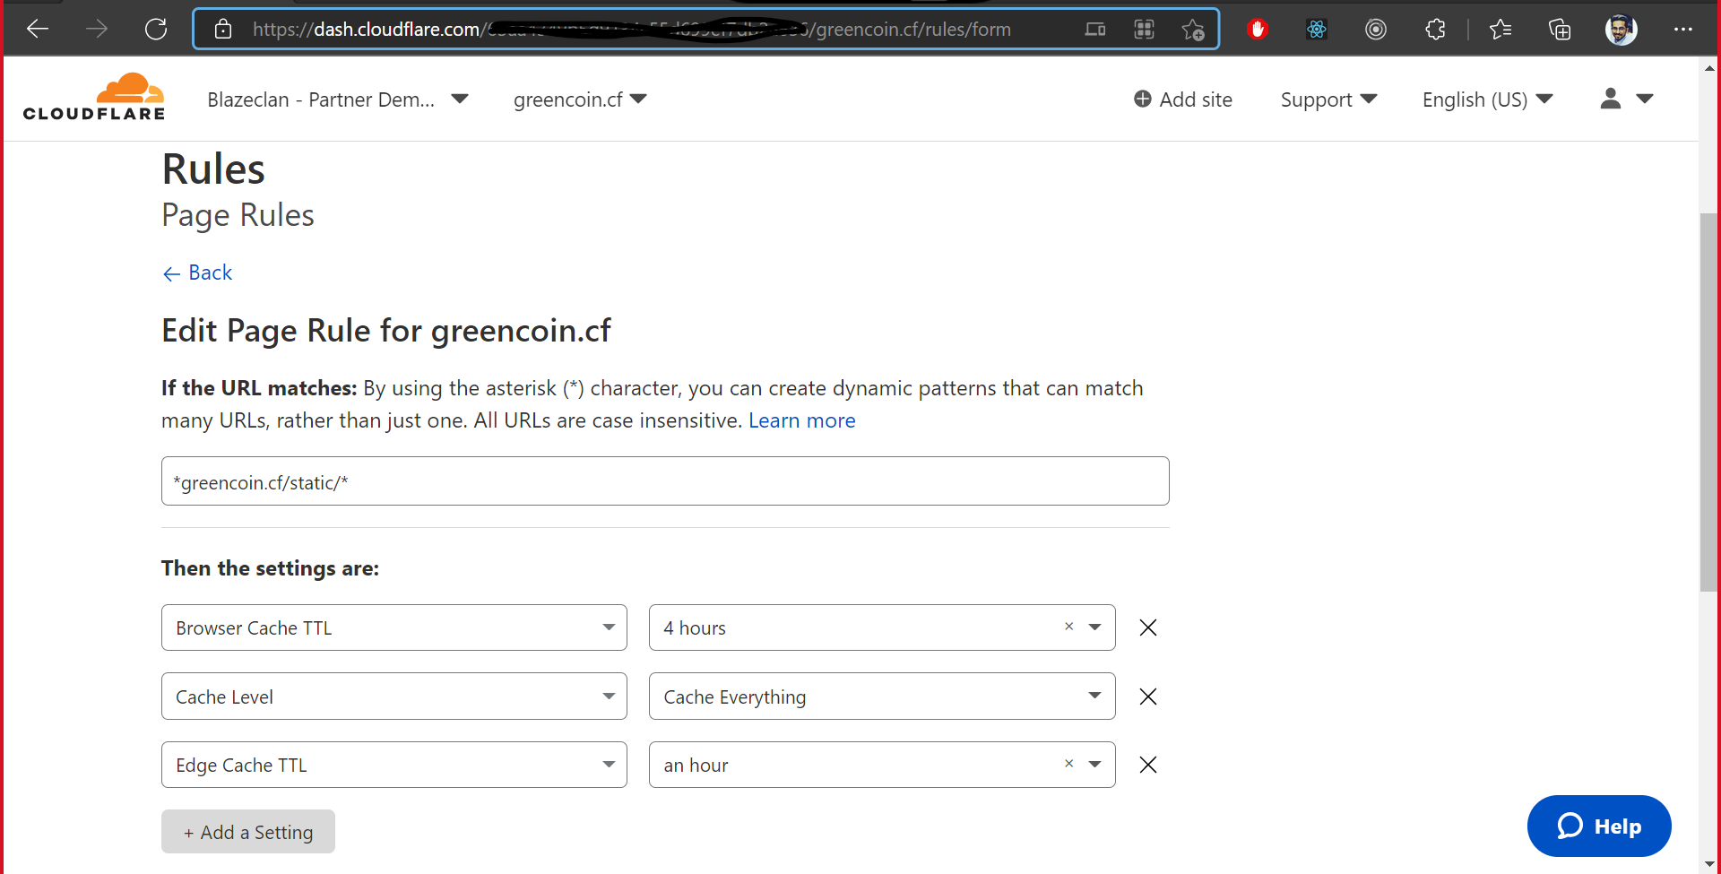

**4.C. Turn on webp conversion for pictures on Cloudflare and do a size comparison of both version of the picture, with and without webp**

Before WebP-> Content-length: 961688

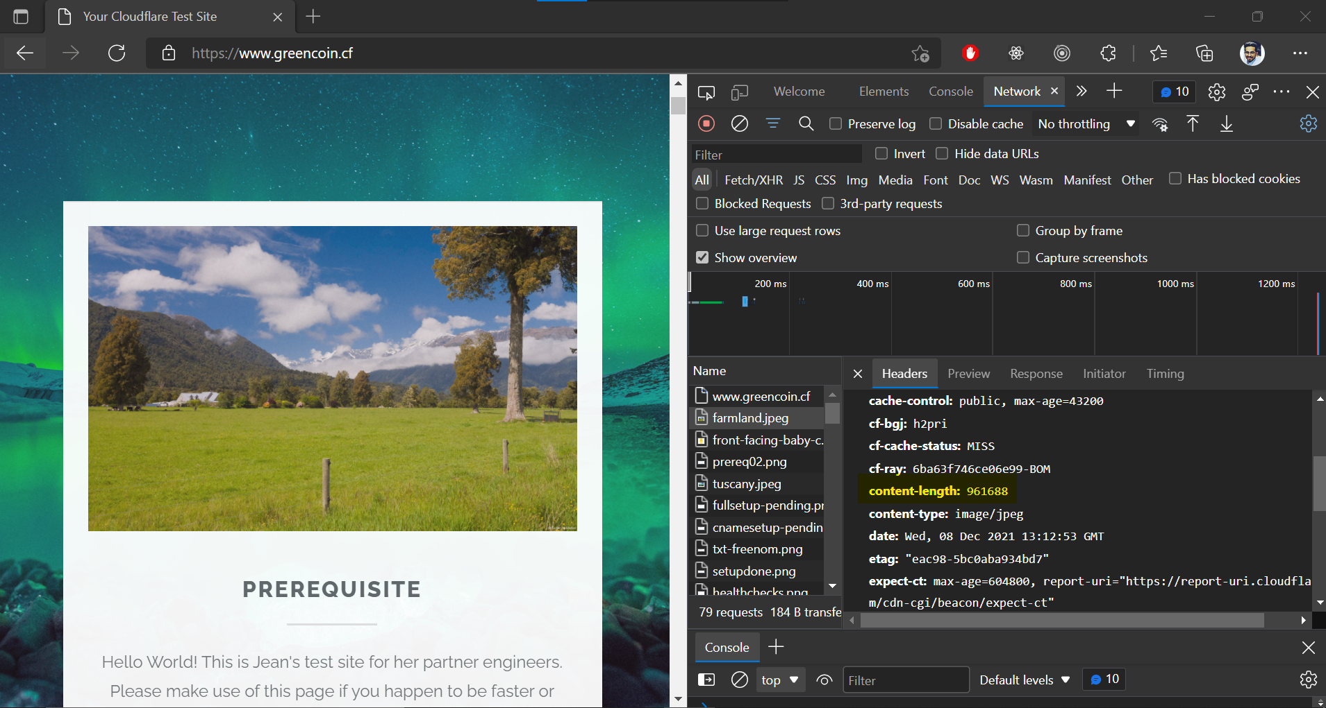

After WEBP->

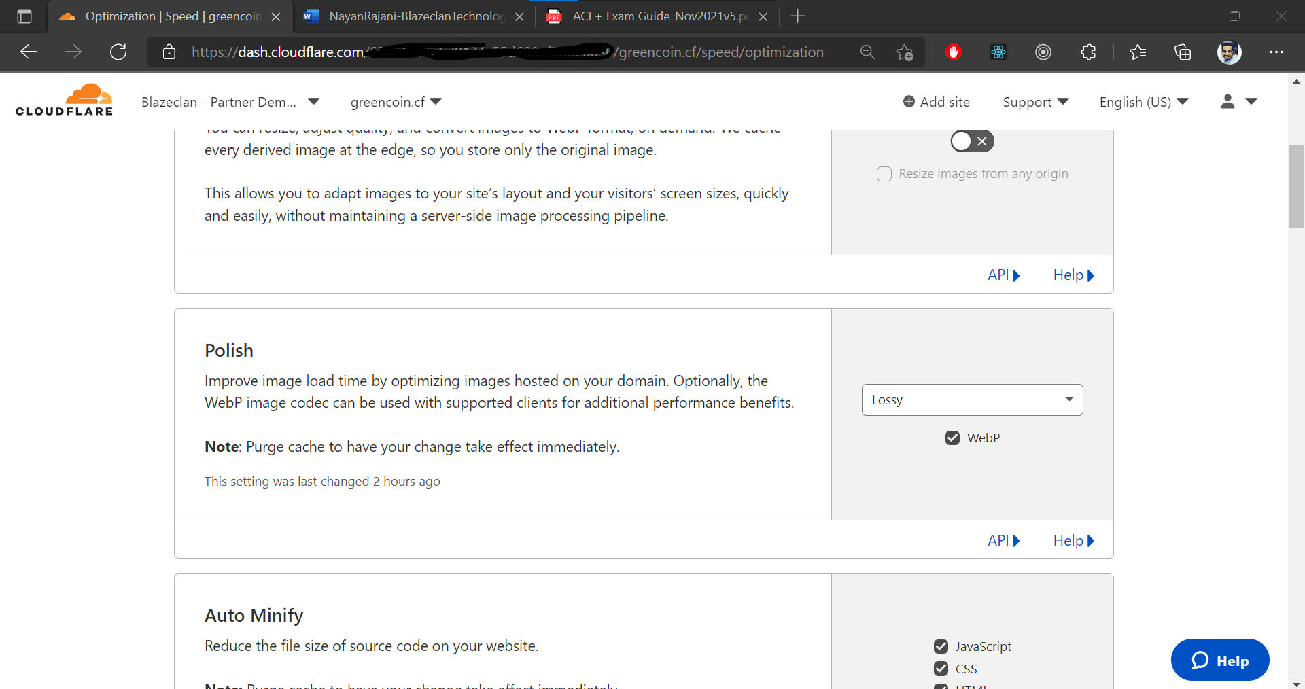

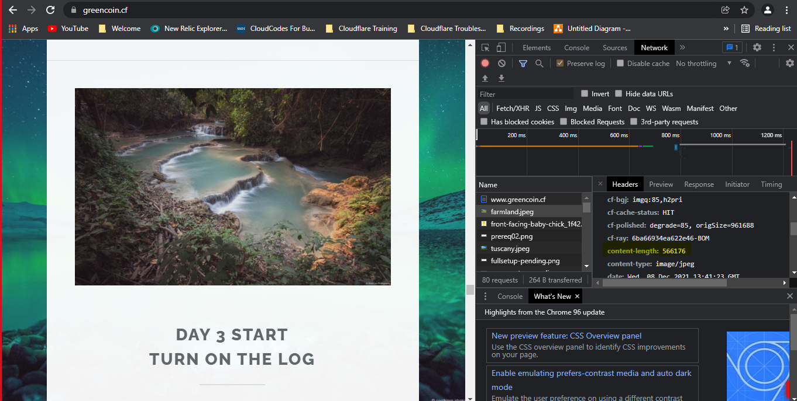

**4.D. Show the steps to purge all cache under the folder app.greencoin.cf/static**

Goto -> Caching-> configuration-> Custom Purge

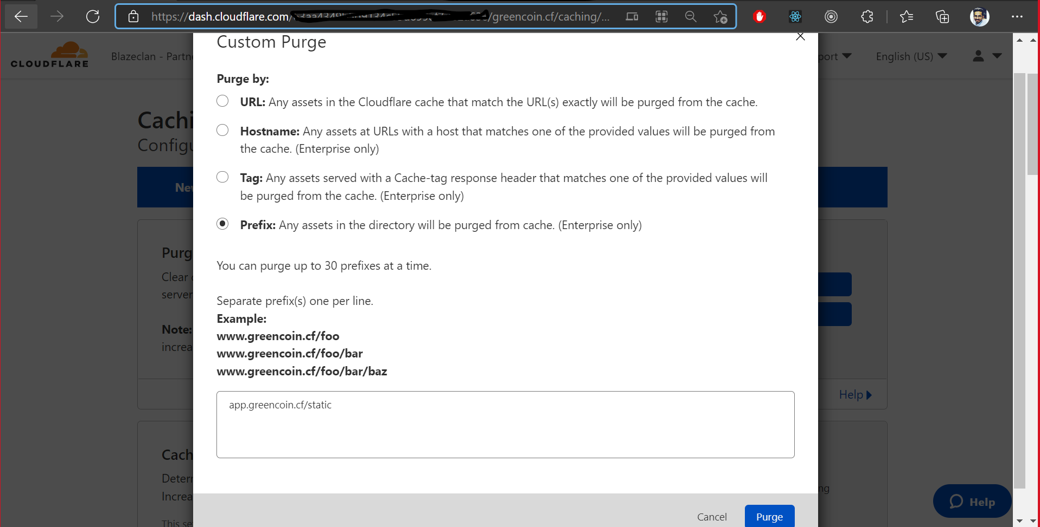

**4.E.**

1. Default Cache from cloudflare
2. 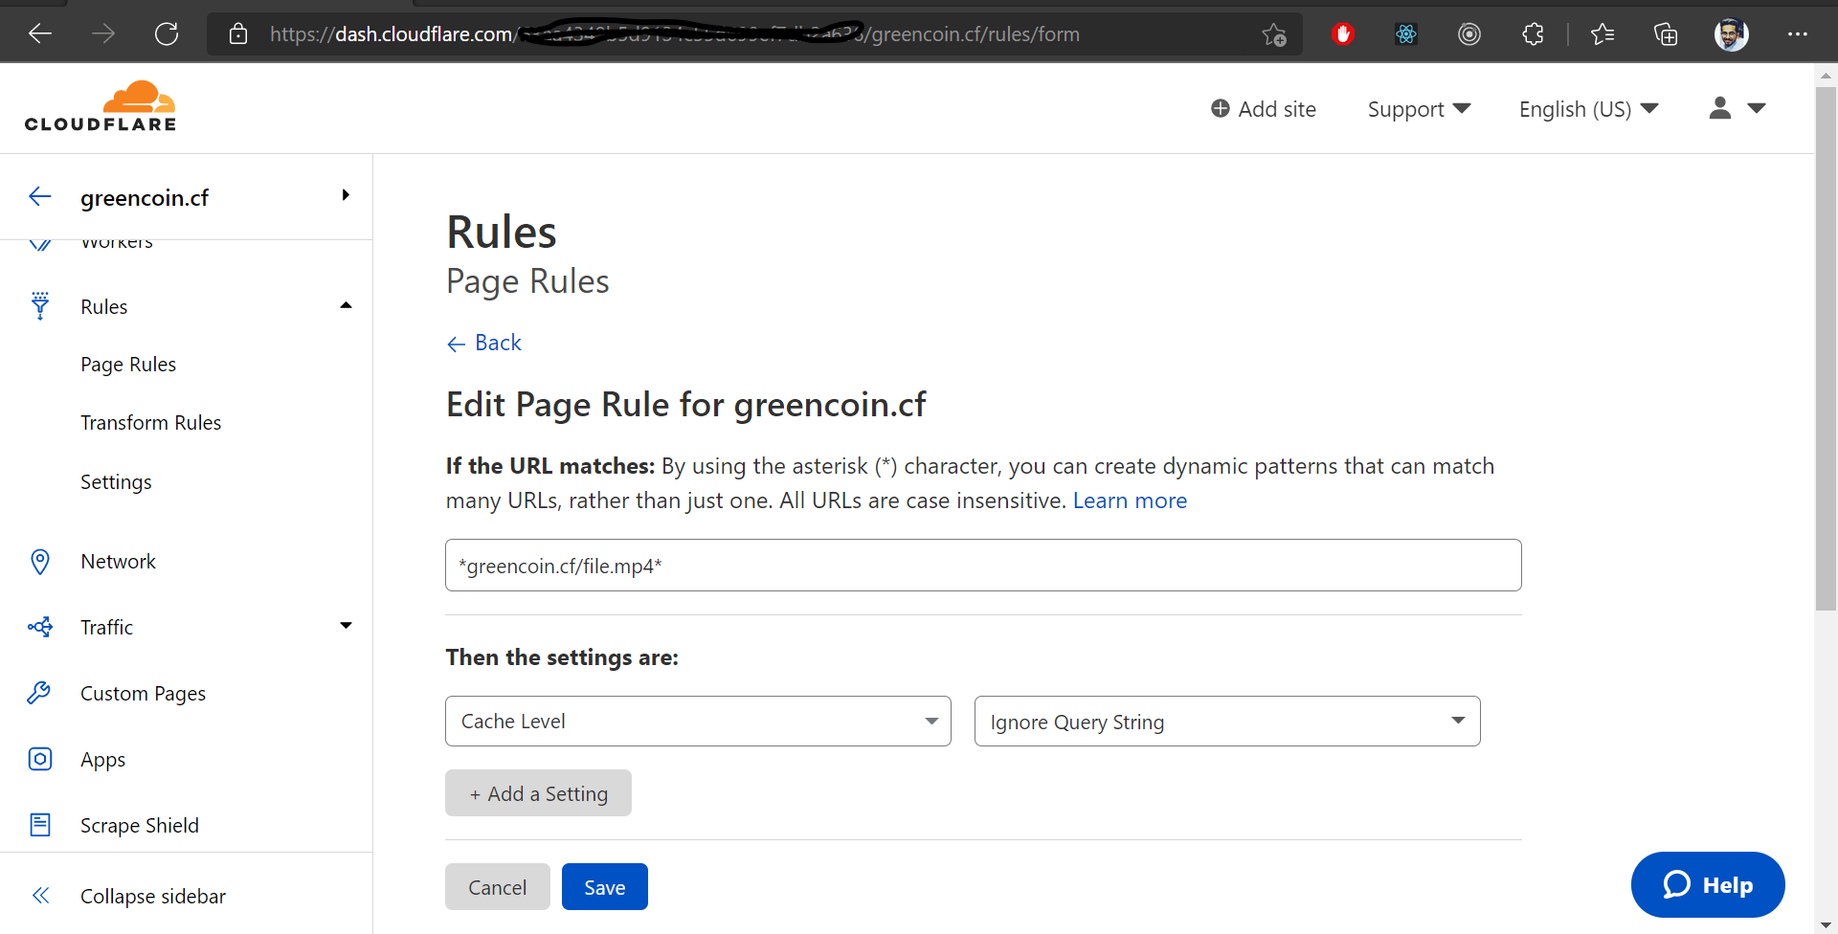
3. Will complete at ASA time, will get better understanding!

**5. User Administration & Log Analytics (5 points)**

**User Administration:**

**A. Show the screenshot where you can check which account member changed any Cloudflare configuration**

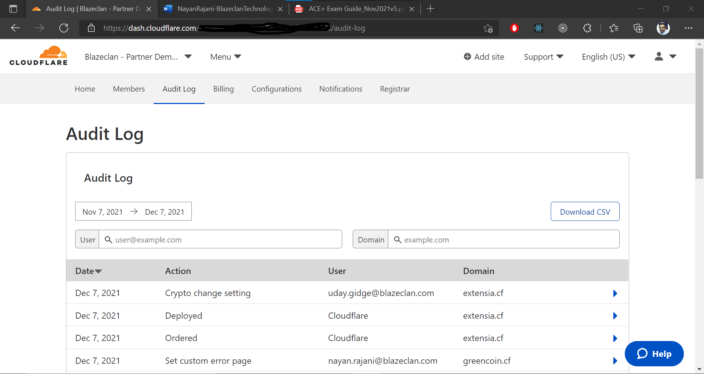

**B. Show the screenshot where you personalize any block and error pages for your domain**

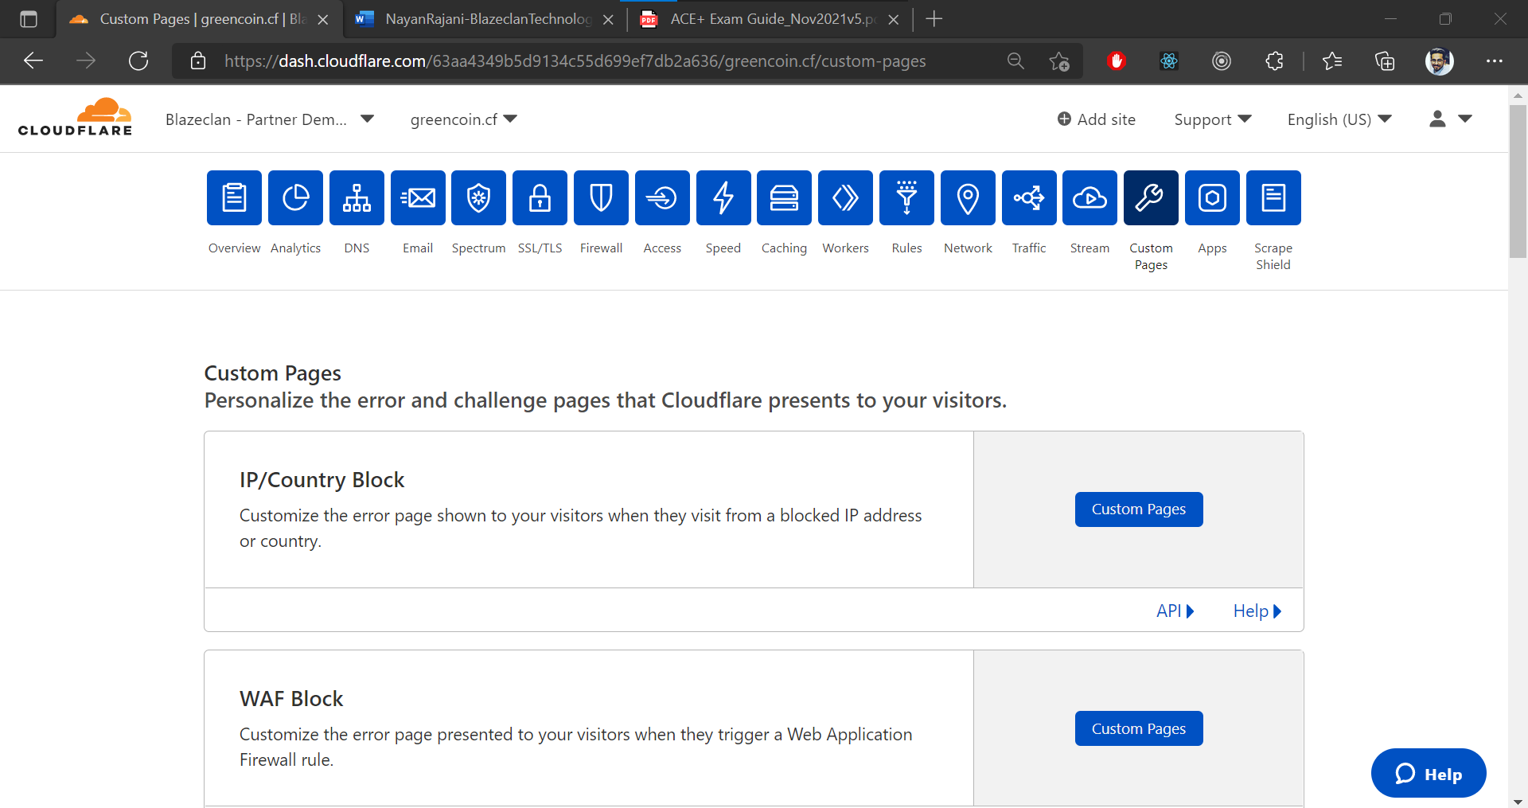

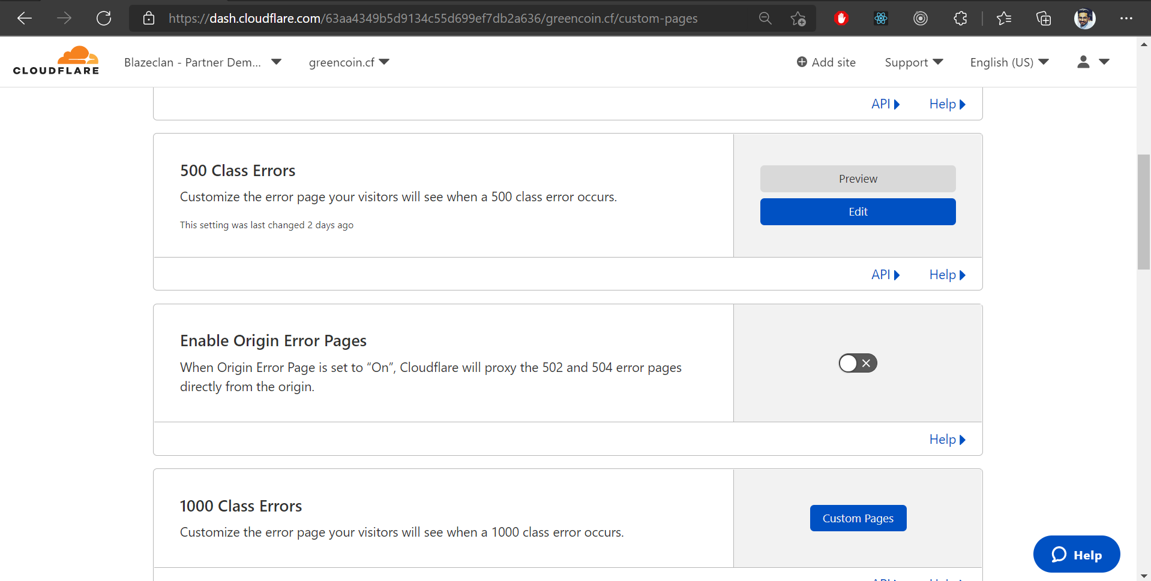

**Logs and Analytics**

**C. Show the screenshot to set up Logpush jobs to any Logpush target for HTTP requests, Audit Log and Firewall events**

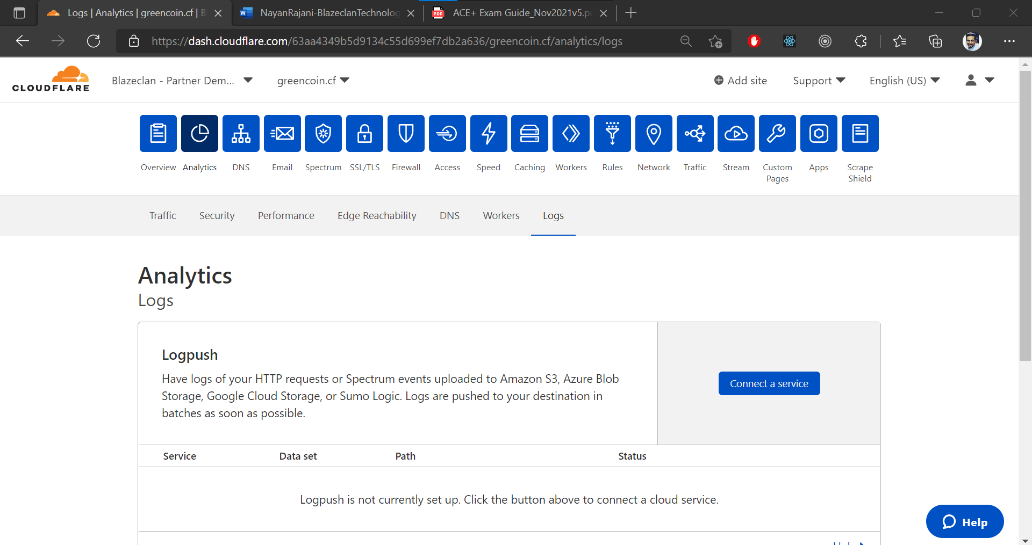

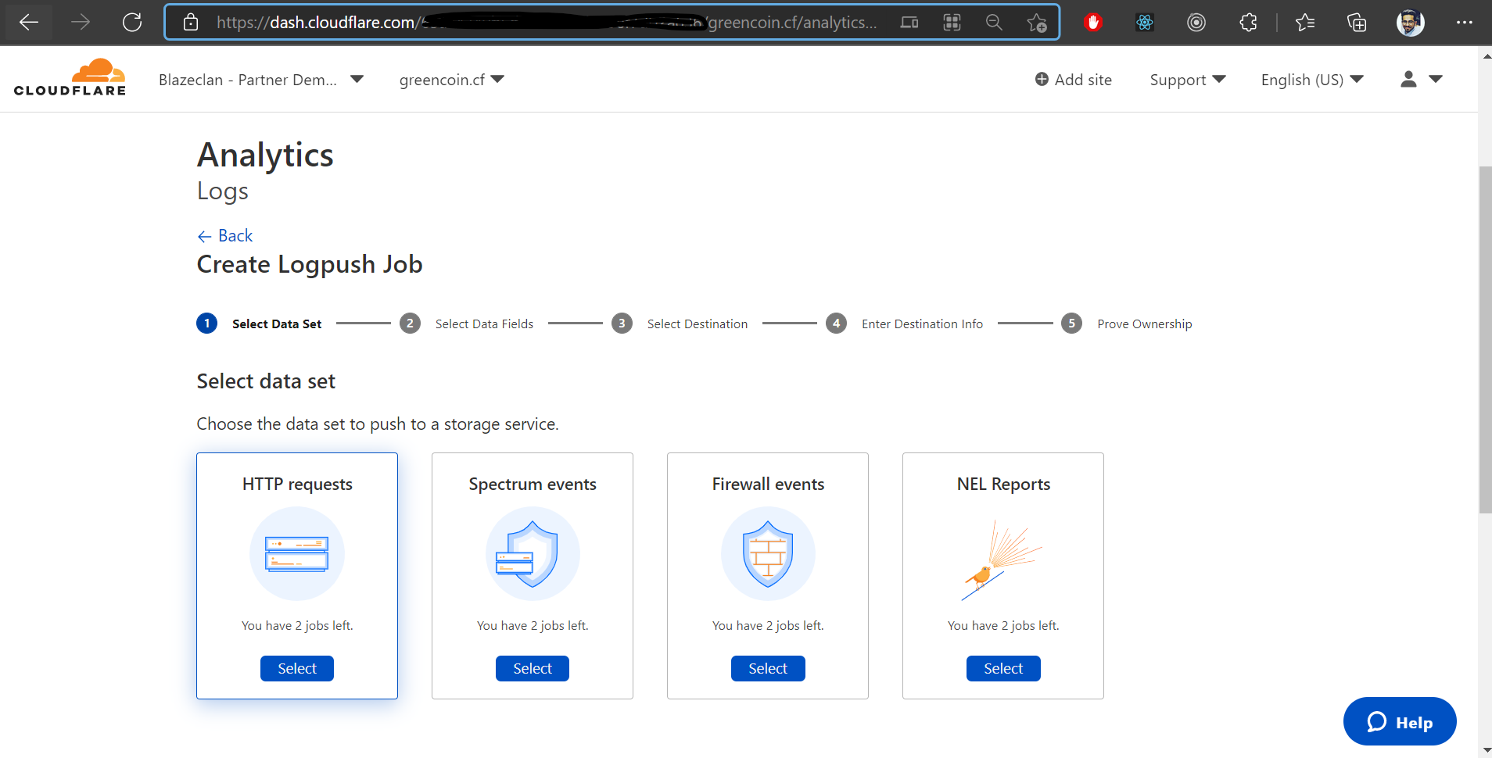

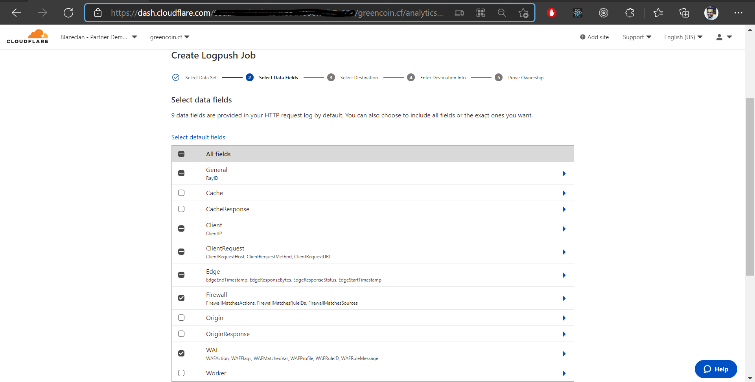

* Selected the **firewall** option also!
* Selected AWS S3

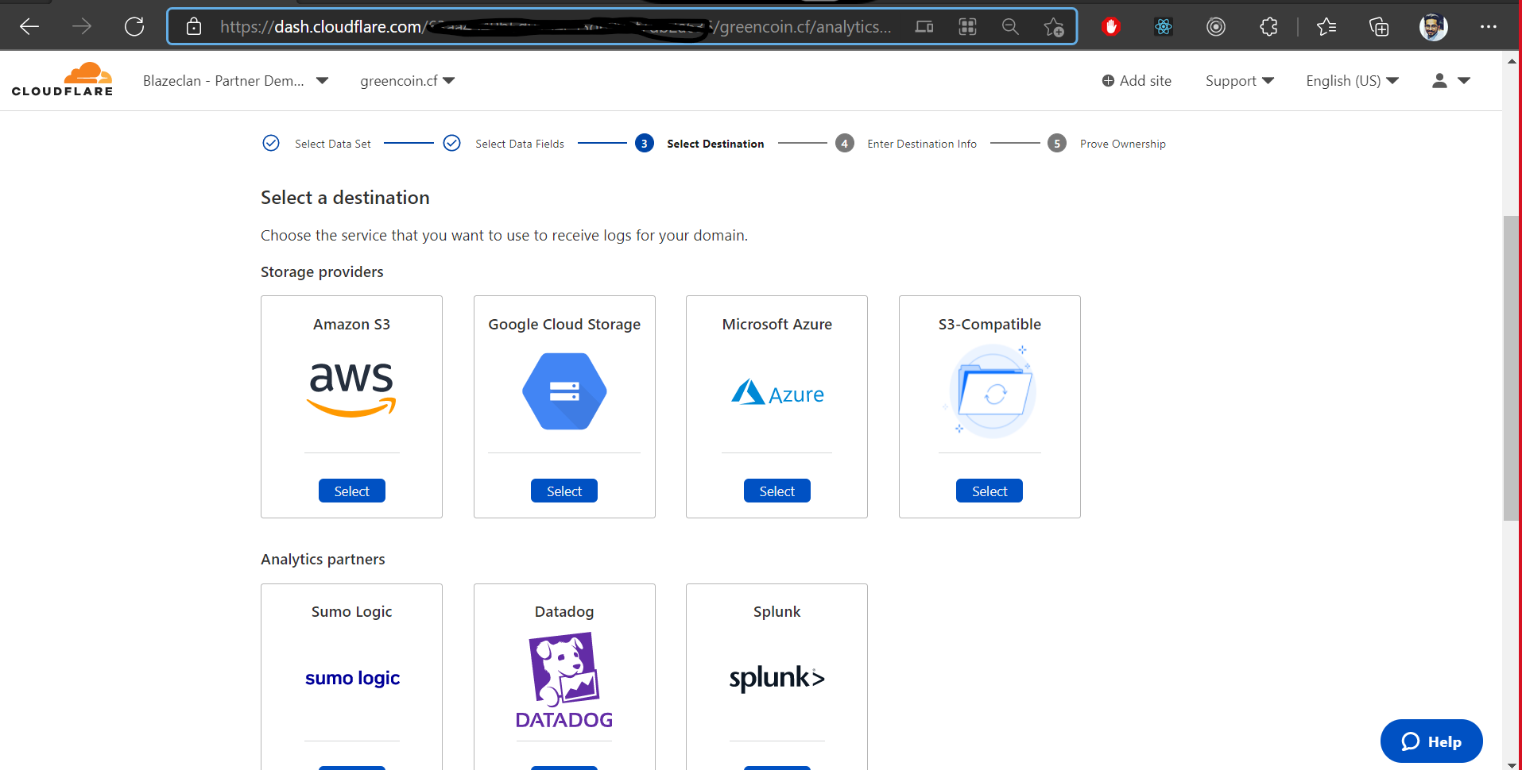

* After this we have to go for S3 bucket Url and destination and after this we have to go for prove ownership!

**D. Show the screenshot of Postman or curl to run API call and output to turn on Logpull for your zone.**

GET- <https://api.cloudflare.com/client/v4/zones/<ZONEID>/logs/control/retention/flag>

Header- Email and API token (Global)

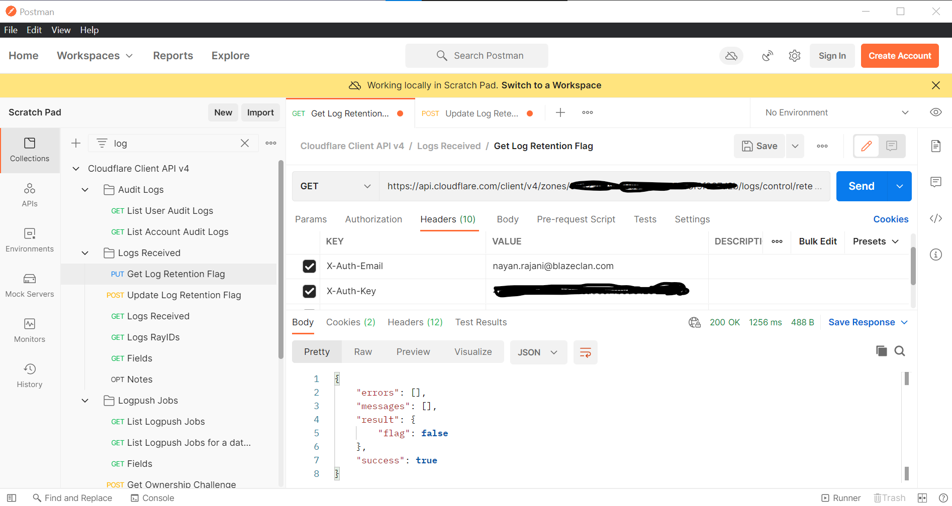

POST- <https://api.cloudflare.com/client/v4/zones/<ZONEID>/logs/control/retention/flag>

Body- {“flag”: true}

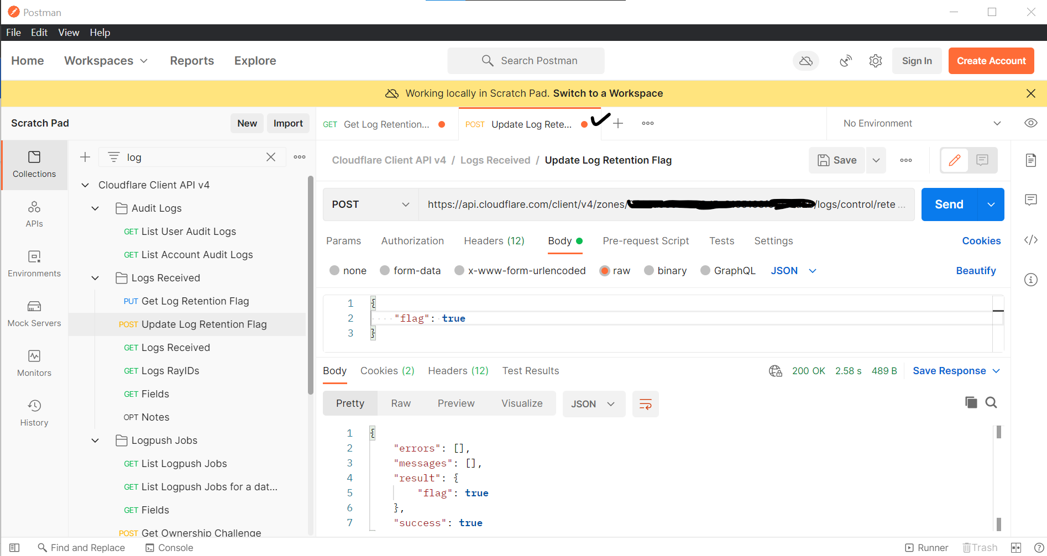

**E. Show the screenshot of Postman or curl to run API call to download your log for the previous 1 hour using Logpull, while redacting your authentication key**

Command- curl -s -H "X-Auth-Email: <Email>" -H "X-Auth-Key: <Auth Key>" "<https://api.cloudflare.com/client/v4/zones/ < Zone>ID>/logs/received?start=2021-12-04T14:17:06Z&end=2021-12-04T15:17:06Z&fields=$(curl -s -H "X-Auth-Email: <Email> " -H "X-Auth-Key: <Auth Key> " "https://api.cloudflare.com/client/v4/zones/ [< Zone](https://api.cloudflare.com/client/v4/zones/ < Zone)ID> /logs/received/fields" | jq '. | to_entries[] | .key' -r | paste -sd "," -)&timestamps=RFC3339”

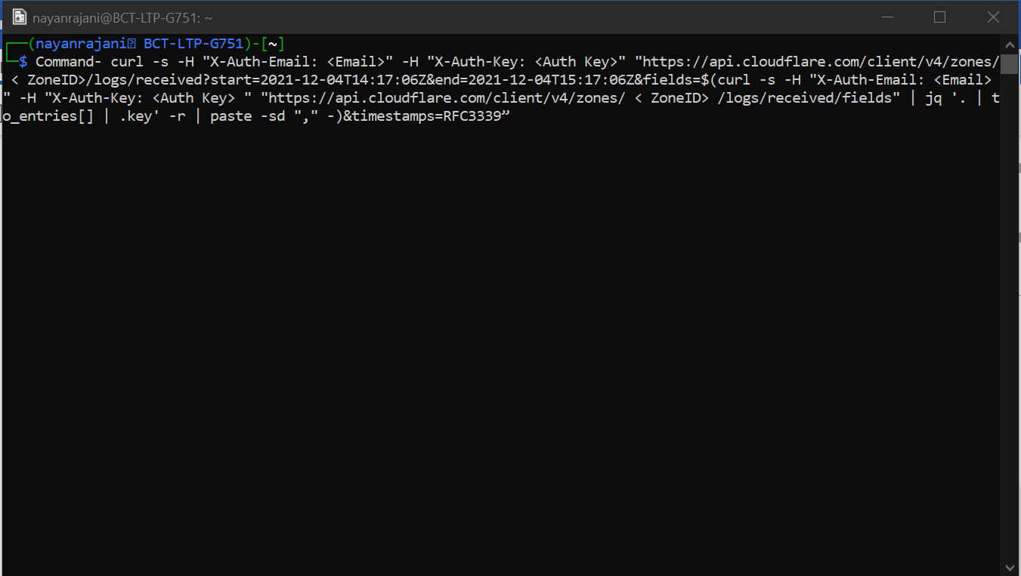

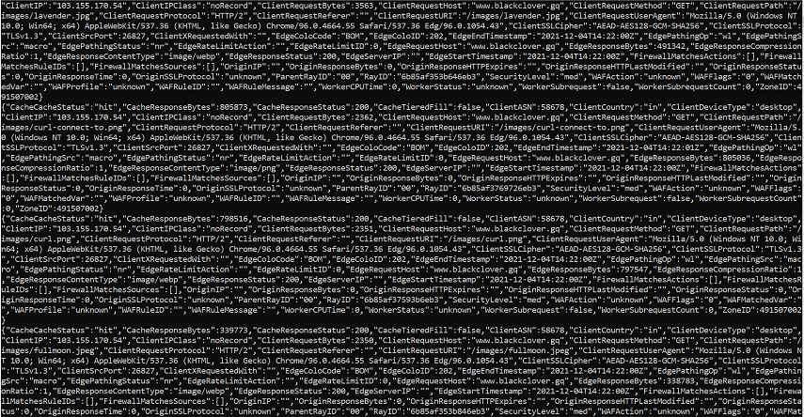

**6. Client API (15 points)**

**6. A. Using Postman, GET the JSON response of the zone settings of your zone**

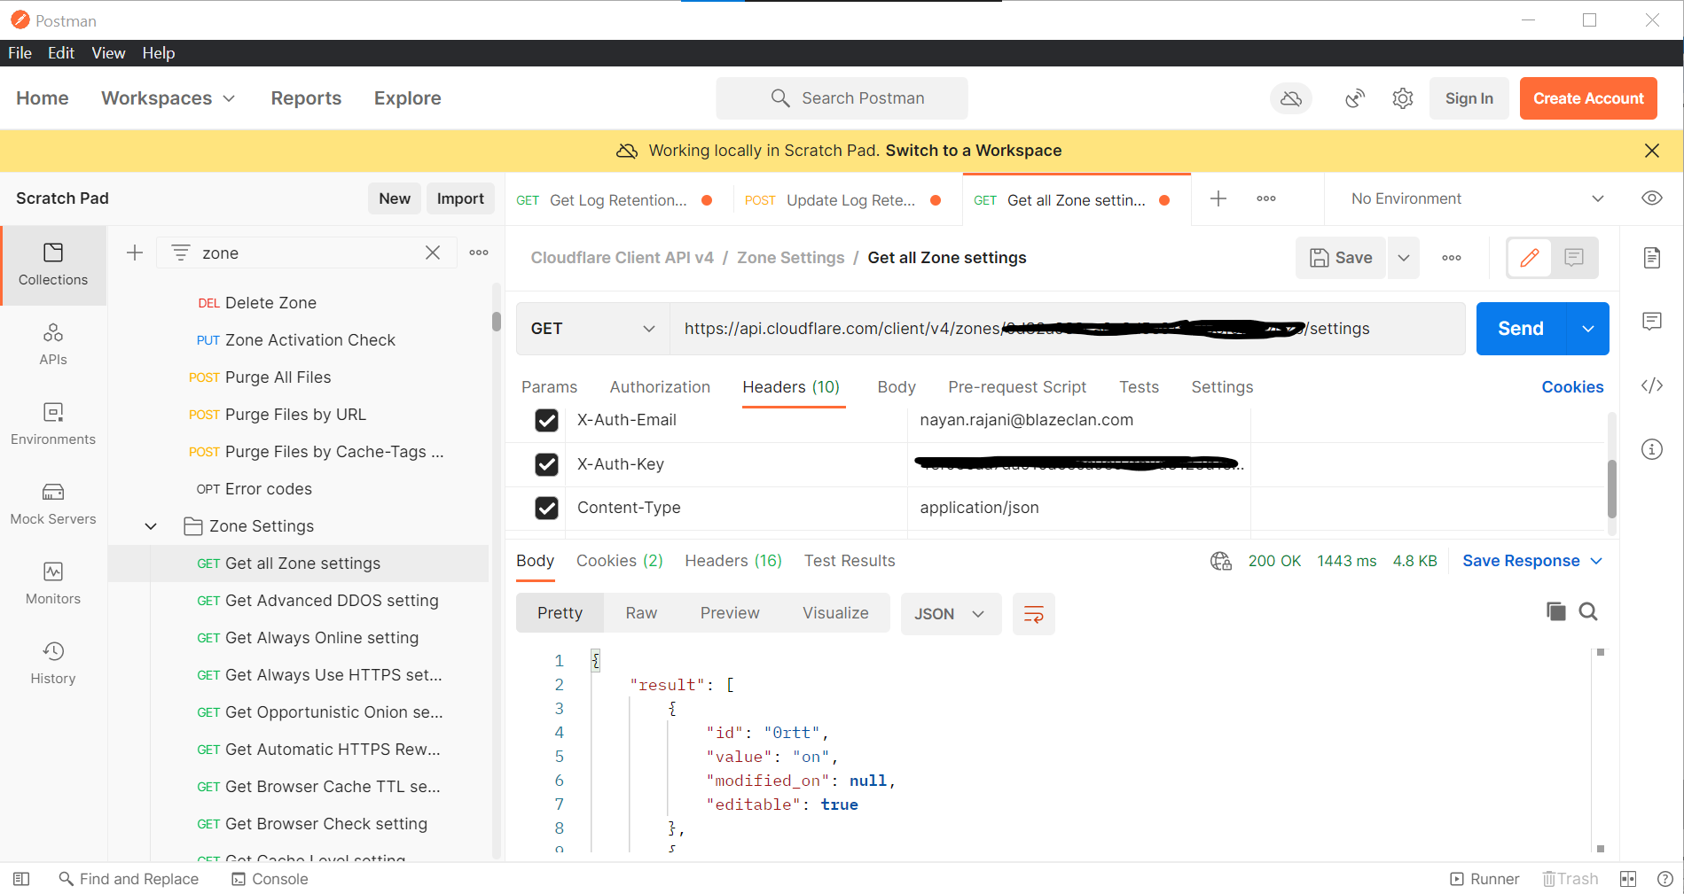

Response-> {"result":[{"id":"0rtt","value":"on","modified_on":null,"editable":true},{"id":"advanced_ddos","value":"on","modified_on":null,"editable":false},{"id":"always_online","value":"on","modified_on":null,"editable":true},{"id":"always_use_https","value":"on","modified_on":"2021-12-06T16:37:58.302853Z","editable":true},{"id":"automatic_https_rewrites","value":"off","modified_on":null,"editable":true},{"id":"brotli","value":"on","modified_on":"2021-12-07T04:19:11.732723Z","editable":true},{"id":"browser_cache_ttl","value":14400,"modified_on":null,"editable":true},{"id":"browser_check","value":"on","modified_on":null,"editable":true},{"id":"cache_level","value":"aggressive","modified_on":"2021-12-07T07:31:33.874056Z","editable":true},{"id":"challenge_ttl","value":1800,"modified_on":null,"editable":true},{"id":"ciphers","value":[],"modified_on":null,"editable":true},{"id":"cname_flattening","value":"flatten_at_root","modified_on":null,"editable":true},{"id":"development_mode","value":"off","modified_on":null,"editable":true},{"id":"early_hints","value":"off","modified_on":null,"editable":true},{"id":"edge_cache_ttl","value":7200,"modified_on":null,"editable":true},{"id":"email_obfuscation","value":"on","modified_on":null,"editable":true},{"id":"filter_logs_to_cloudflare","value":"off","modified_on":null,"editable":true},{"id":"hotlink_protection","modified_on":null,"value":"off","editable":true},{"id":"http2","value":"on","modified_on":null,"editable":true},{"id":"http3","value":"off","modified_on":null,"editable":true},{"id":"ip_geolocation","value":"on","modified_on":null,"editable":true},{"id":"ipv6","value":"on","modified_on":"2021-12-06T12:33:31.548757Z","editable":true},{"id":"log_to_cloudflare","value":"on","modified_on":null,"editable":true},{"id":"max_upload","value":100,"modified_on":null,"editable":true},{"id":"min_tls_version","value":"1.0","modified_on":null,"editable":true},{"id":"minify","value":{"js":"on","css":"on","html":"on"},"modified_on":"2021-12-07T04:19:07.760373Z","editable":true},{"id":"mirage","value":"on","modified_on":"2021-12-07T04:19:37.882213Z","editable":true},{"id":"mobile_redirect","value":{"status":"off","mobile_subdomain":null,"strip_uri":false},"modified_on":null,"editable":true},{"id":"opportunistic_encryption","value":"off","modified_on":null,"editable":true},{"id":"opportunistic_onion","value":"on","modified_on":null,"editable":true},{"id":"orange_to_orange","value":"off","modified_on":null,"editable":true},{"id":"origin_error_page_pass_thru","value":"off","modified_on":null,"editable":true},{"id":"polish","value":"lossy","modified_on":"2021-12-07T04:18:56.530269Z","editable":true},{"id":"prefetch_preload","value":"off","modified_on":null,"editable":true},{"id":"privacy_pass","value":"on","modified_on":null,"editable":true},{"id":"proxy_read_timeout","value":"100","modified_on":null,"editable":true},{"id":"pseudo_ipv4","value":"off","modified_on":null,"editable":true},{"id":"response_buffering","value":"off","modified_on":null,"editable":true},{"id":"rocket_loader","value":"on","modified_on":"2021-12-07T04:19:34.891571Z","editable":true},{"id":"security_header","modified_on":null,"value":{"strict_transport_security":{"enabled":false,"max_age":0,"include_subdomains":false,"preload":false,"nosniff":false}},"editable":true},{"id":"security_level","value":"medium","modified_on":null,"editable":true},{"id":"server_side_exclude","value":"on","modified_on":null,"editable":true},{"id":"sort_query_string_for_cache","value":"off","modified_on":null,"editable":true},{"id":"ssl","value":"full","modified_on":null,"certificate_status":"none","validation_errors":[],"editable":true},{"id":"tls_1_2_only","value":"off","modified_on":null,"editable":true},{"id":"tls_1_3","value":"zrt","modified_on":null,"editable":true},{"id":"tls_client_auth","value":"off","modified_on":null,"editable":true},{"id":"true_client_ip_header","value":"off","modified_on":null,"editable":true},{"id":"visitor_ip","value":"on","modified_on":null,"editable":true},{"id":"waf","value":"on","modified_on":"2021-12-06T16:39:54.550518Z","editable":true},{"id":"webp","value":"on","modified_on":"2021-12-07T04:18:59.859169Z","editable":true},{"id":"websockets","value":"on","modified_on":null,"editable":true}],"success":true,"errors":[],"messages":[]}

**6.B Create an API token that can be used to purge cache at your domain only, valid for 1 week and can be executed from a device coming from your network only**

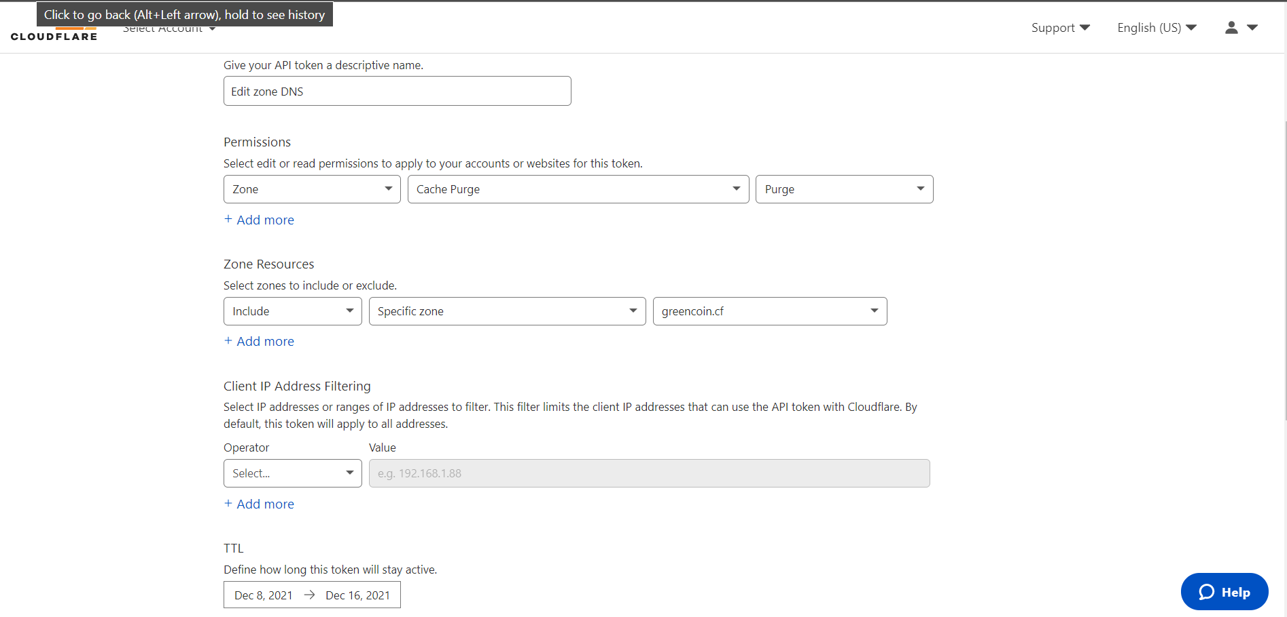

* It requires a client ip that’s why it is empty!!

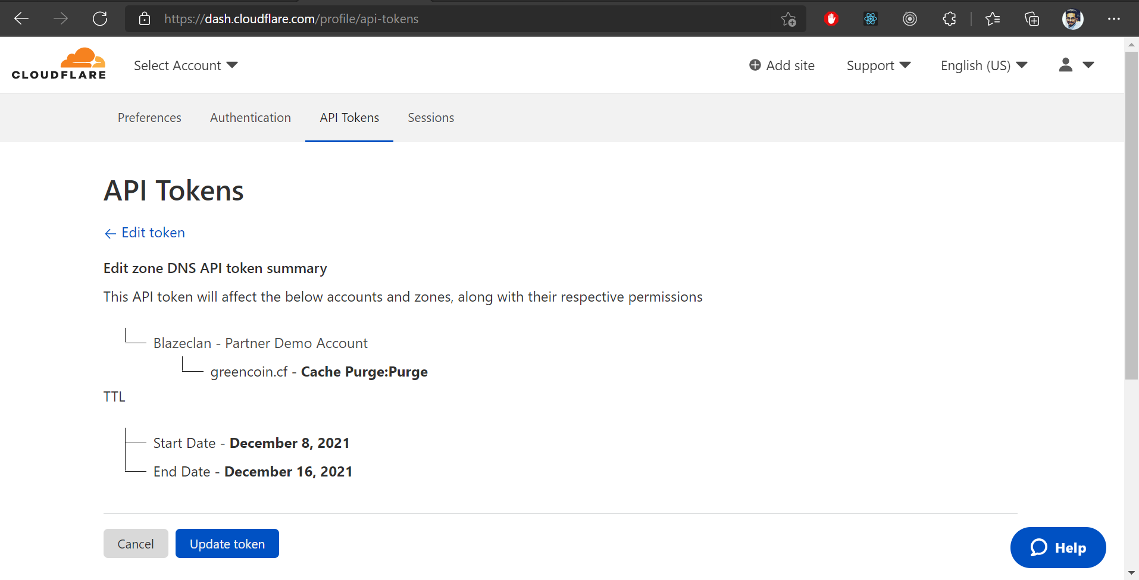

**6. C. Run the API call to purge all the cache from Cloudflare edge using the above API token**

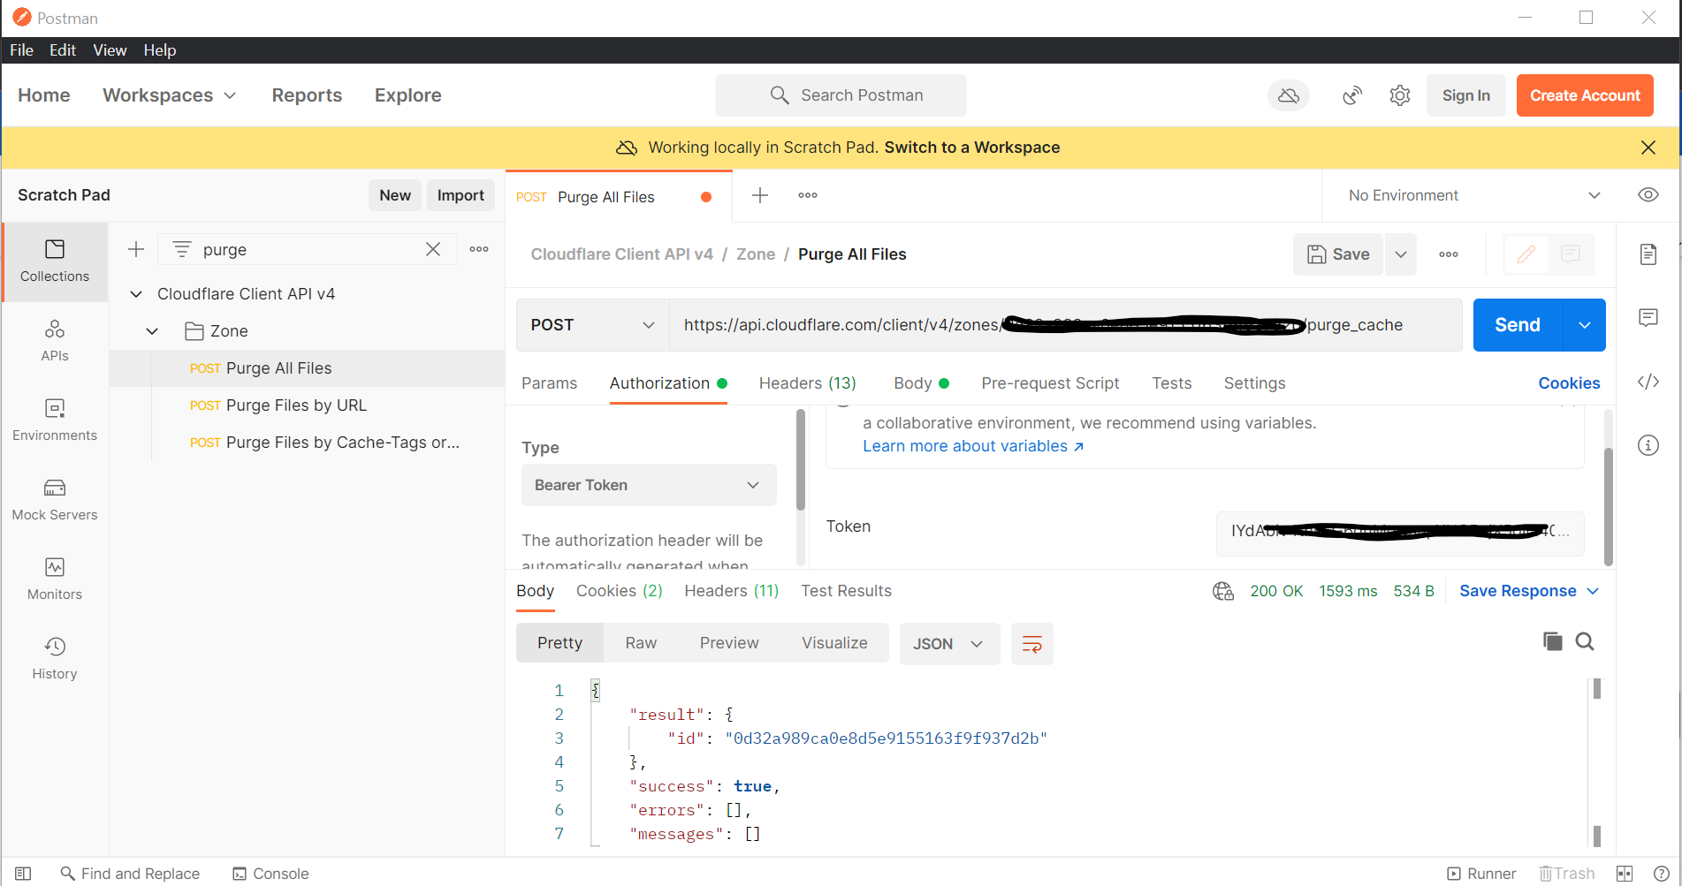

**ADD-ON Optional(s)**

**7. Argo Smart Routing/Tiered Caching (Optional: 2 points)**

**7. A. Turn on Argo Smart routing and show the analytics of improved performance**

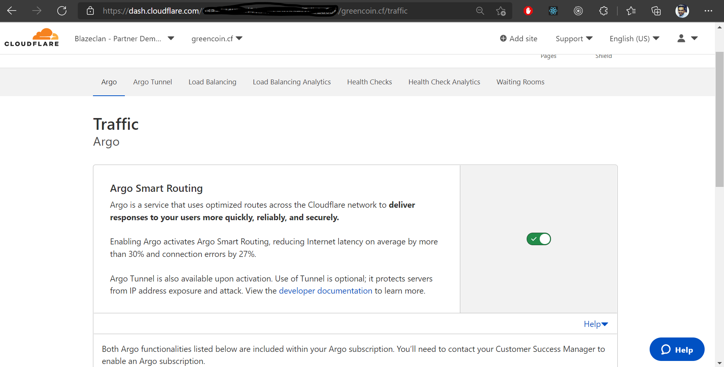

* I tried to make more request to my website, but was not able to show this up, but I have enabled the argo smart routing, and here is the screenshot and it is asking to wait for 48 hours!

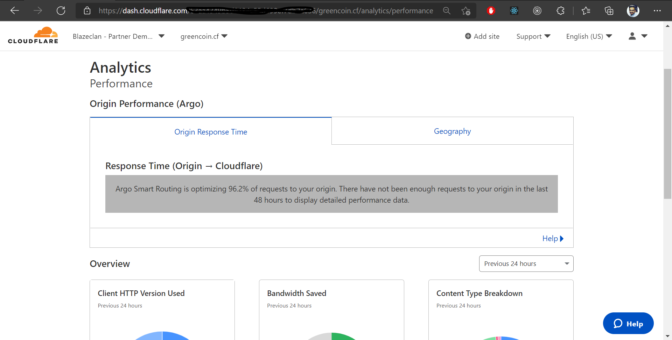

**7. B. Turn on Tiered Caching and set it to Smart Tiered Caching Topology**

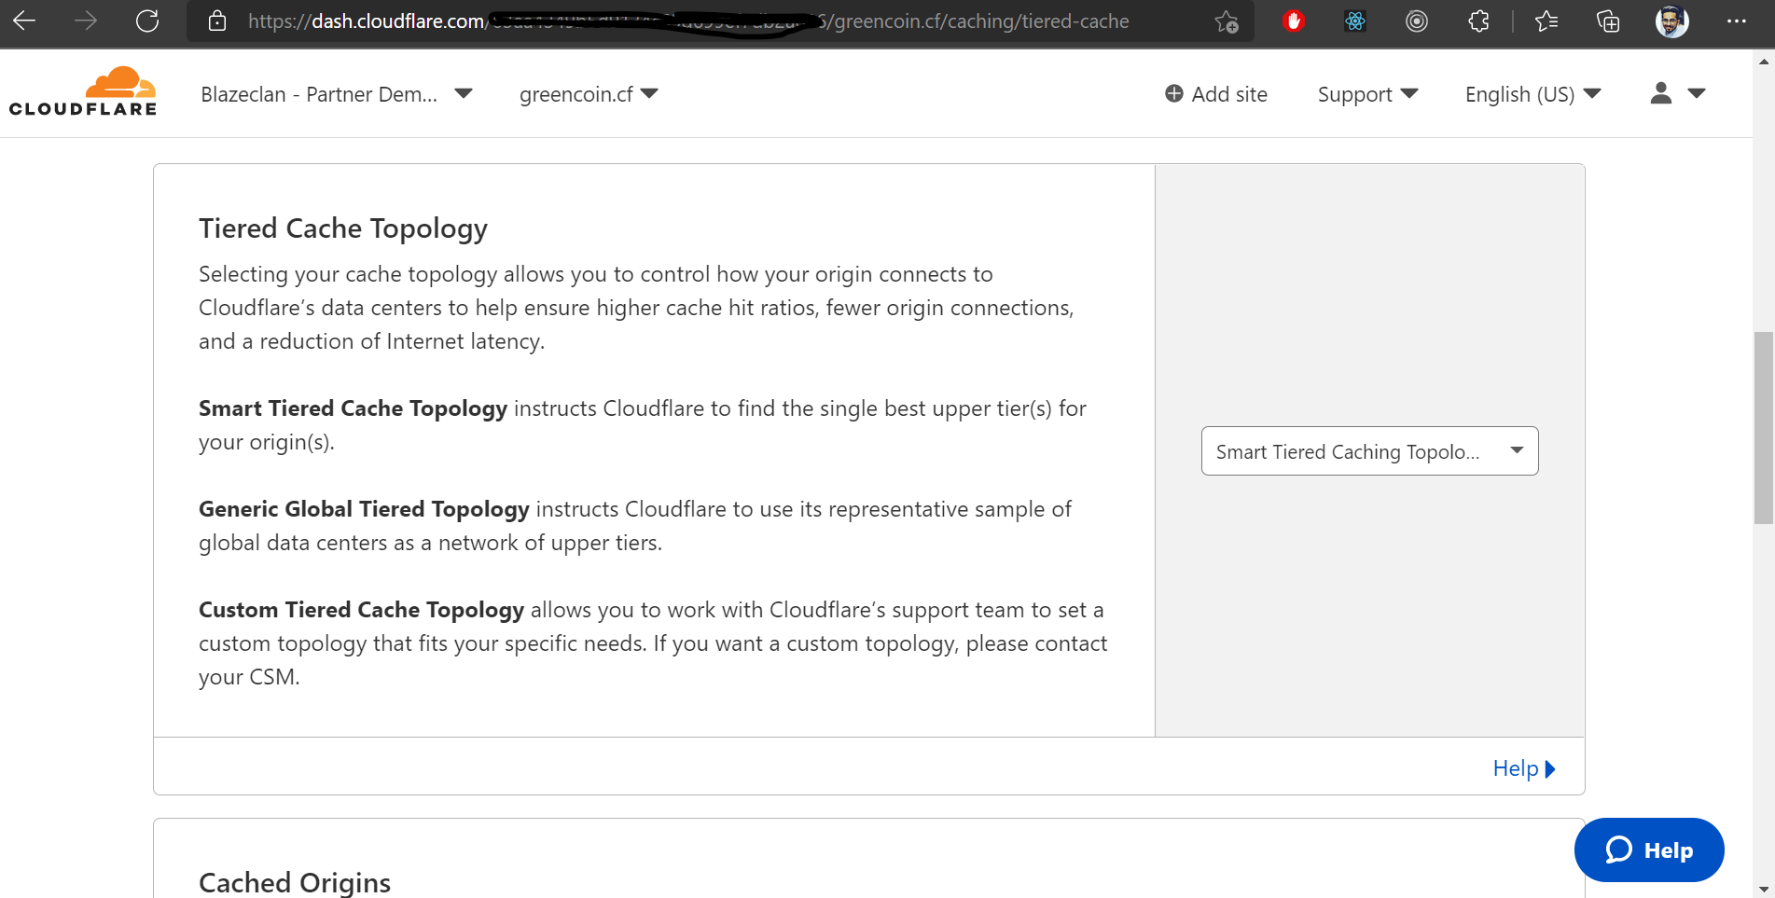

**8. Rate Limiting (Optional: 4 points)**

**A. Create a policy to block any request going to https://api.greencoin.cf for 5 minutes if the request from the same IP Address exceeds 100 times**

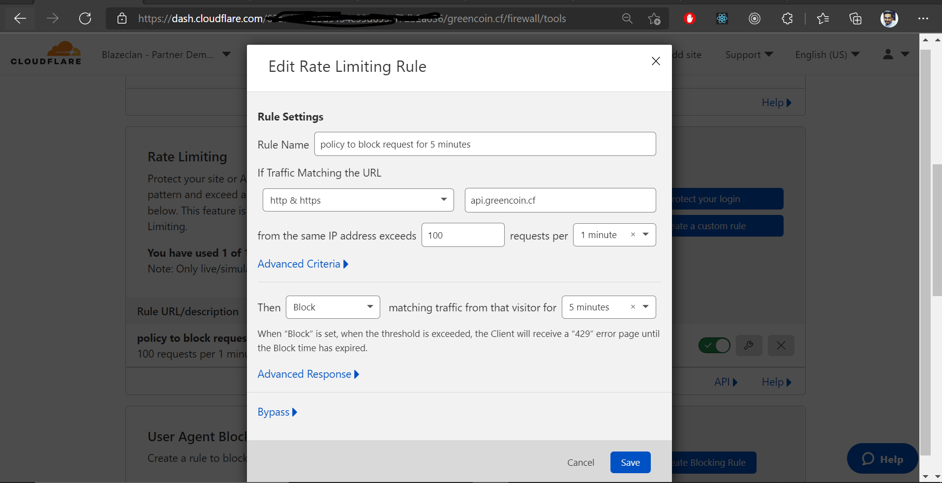

**B. Customize the blocking message to this text message: “Please try again after 5 minutes”**

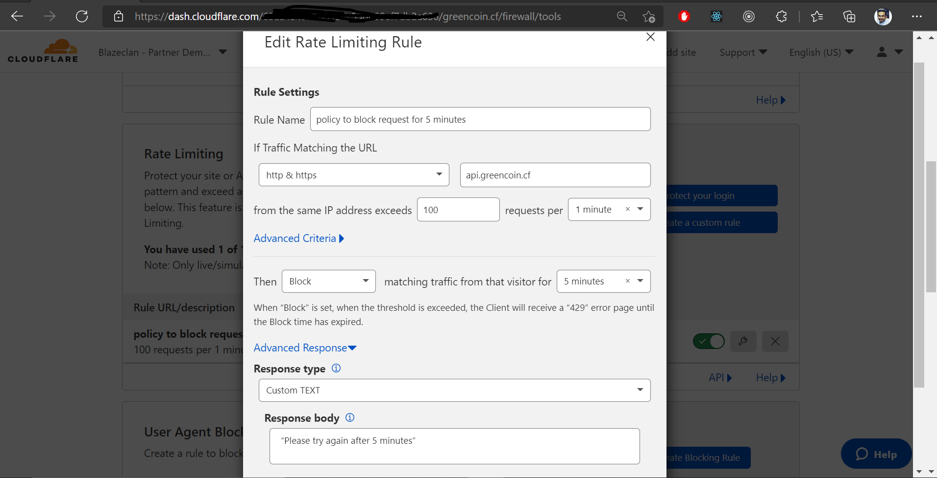

* And added a customized message to try after sometime.

**9. Spectrum (Optional: 5 points)**

**A. Put a ssh server behind the Spectrum and change the edge port to 2022 (instead of 22).**

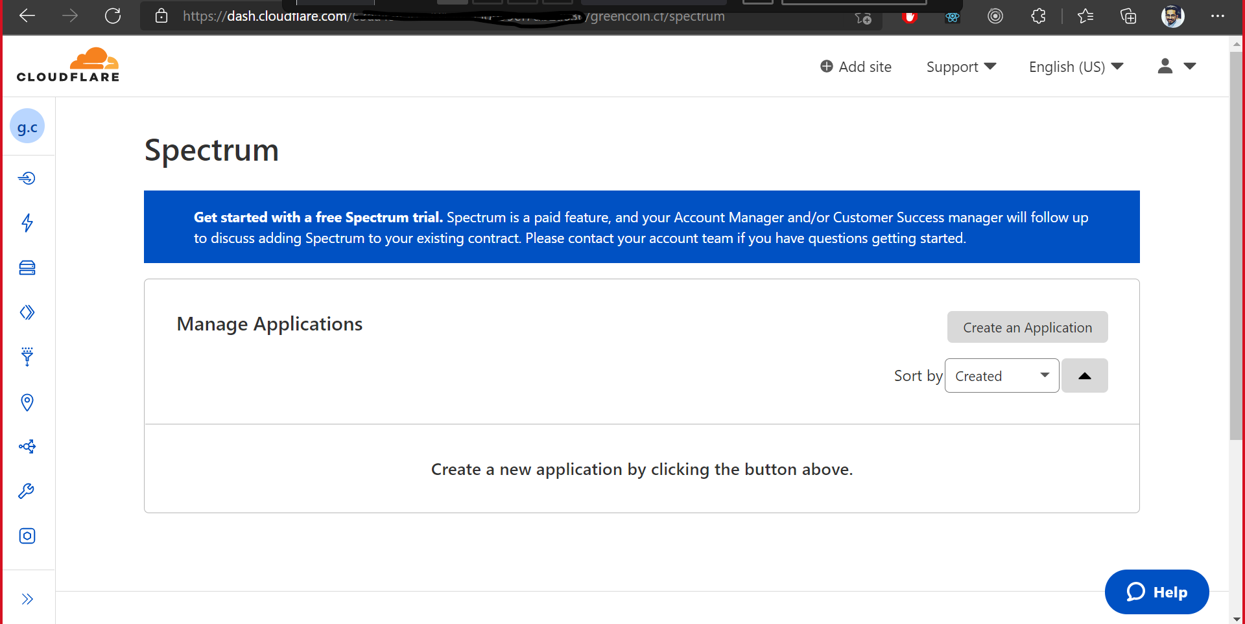

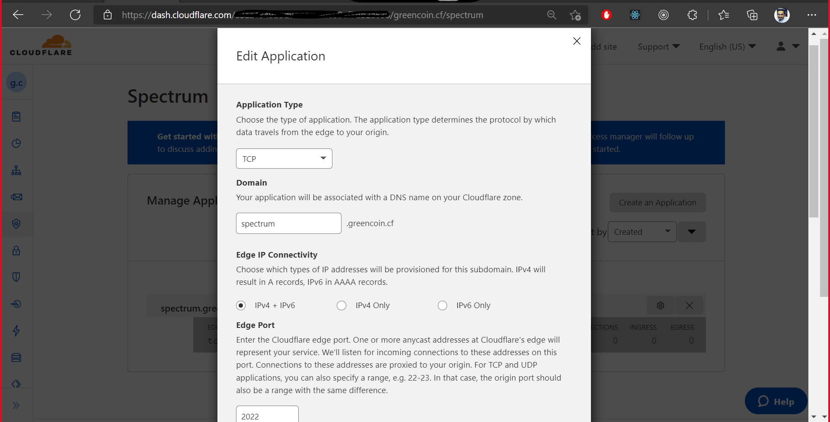

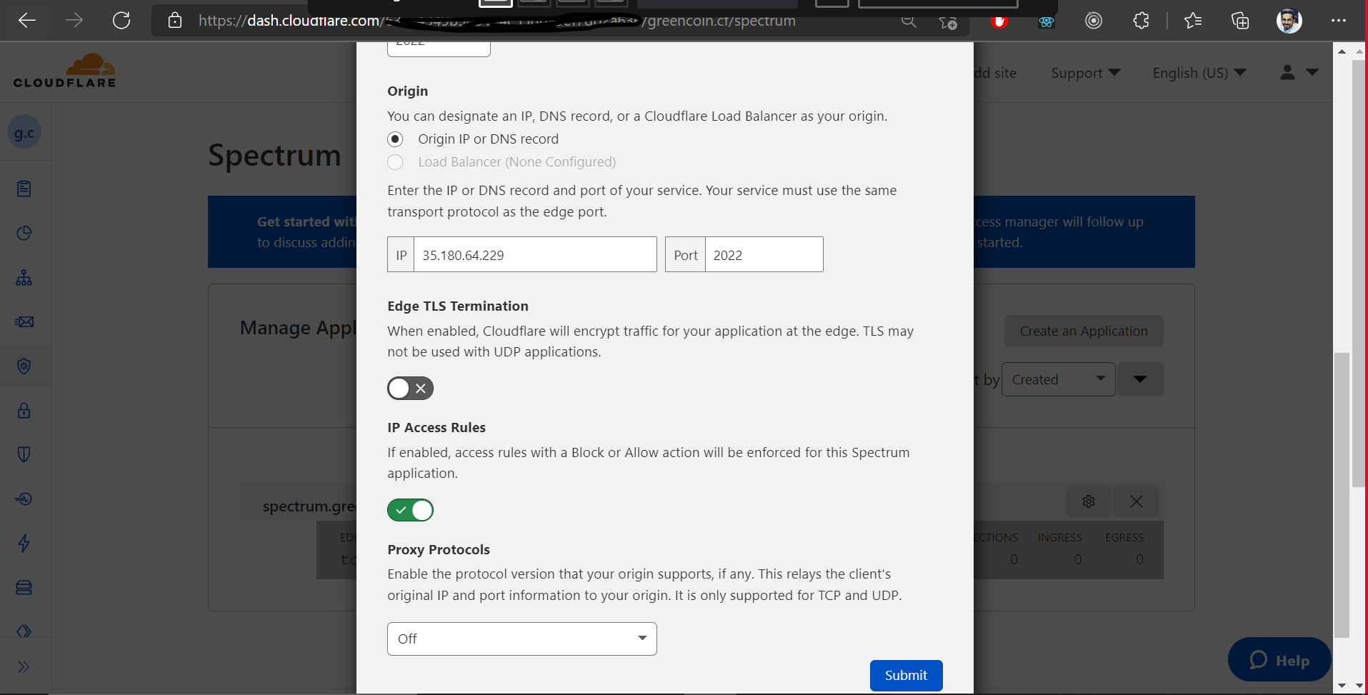

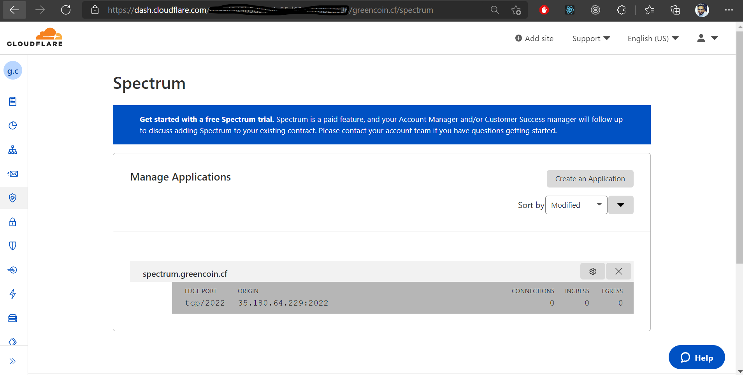

**B. Show login screen to that ssh server using the configured Spectrum hostname**

* Actually, we don’t know much about Spectrum part, but tried to configure something like creating an application on spectrum to use some protocols and Ipv4 +Ipv6 and other configuration part.

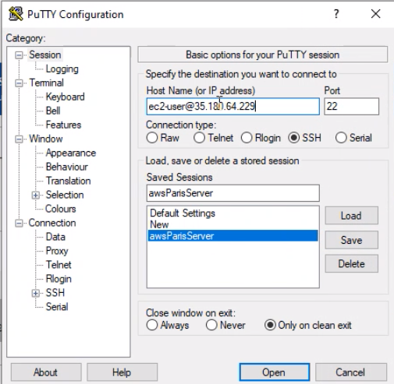 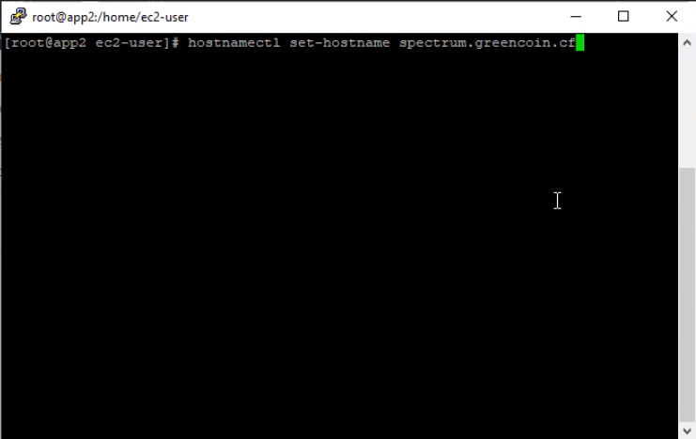

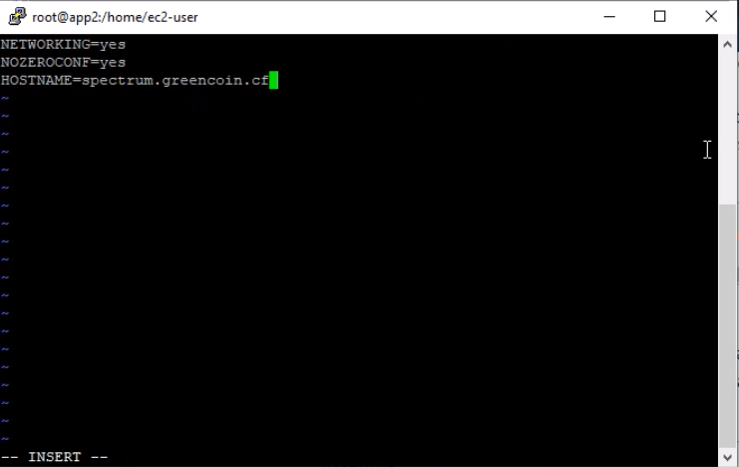

* After this reboot Instance and logging in as a hostname

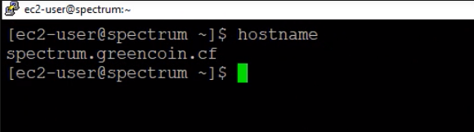

**10. Load Balancing (Optional: 10 points)**

**Set up a Cloudflare Load Balancing between 2 instances under lb. with these specifications:**

**a. Each instance will reside in different pool, name it pool1 and pool, with pool1 as the fallback pool**

**b. Configure a mechanism to check every 10 minutes if https://lb./monitor.txt is not accessible on port 443 within 10 seconds**

**c. Add a traffic steering to route traffic to the fastest pool based on measured latency from health checks**

